

Politecnico di Milano

SOFTWARE ENGINEERING II PROJECT

**_________________________________________________________**

**RASD**

**REQUIREMENTS ANALYSIS AND SPECIFICATION DOCUMENT**

**_________________________________________________________**

*Professor*:

Matteo Giovanni Rossi

*Authors*:

Stefano Vanerio

Agnese Straccia

Cristiano Serafini

*Date*:

23th December 2020

*Version*:

Version 2.0

**CONTENTS**

**1 Introduction**

1.1 Purpose . . . . . . . . . . . . . . . . . . . . . . . . . . . . . . . . . . . . . .

1.2 Context . . . . . . . . . . . . . . . . . . . . . . . . . . . . . . . . . . . . . .

1.3 Scope . . . . . . . . . . . . . . . . . . . . . . . . . . . . . . . . . . . . . . .

1.3.1 Goals . . . . . . . . . . . . . . . . . . . . . . . . . . . . . . . . . .

1.4 Glossary . . . . . . . . . . . . . . . . . . . . . . . . . . . . . . . . . . . . . .

1.4.1 Definitions . . . . . . . . . . . . . . . . . . . . . . . . . . . . . . . .

1.4.2 Acronyms . . . . . . . . . . . . . . . . . . . . . . . . . . . . . . . .

1.5 Document Structure . . . . . . . . . . . . . . . . . . . . . . . . . . . . . . . .

**2 Overall Description**

2.1 Product Perspective . . . . . . . . . . . . . . . . . . . . . . . . . . . . . . . .

2.1.1 System Interfaces . . . . . . . . . . . . . . . . . . . . . . . . . . . . .

2.1.2 Model Structure . . . . . . . . . . . . . . . . . . . . . . . . . . . . . .

2.1.3 State Diagrams . . . . . . . . . . . . . . . . . . . . . . . . . . . . . .

2.2 Product Functions . . . . . . . . . . . . . . . . . . . . . . . . . . . . . . . . .

2.2.1 Line Up Function . . . . . . . . . . . . . . . . . . . . . . . . . . . . . 2.2.2 Book A Visit Function . . . . . . . . . . . . . . . . . . . . . . . . . .

2.2.2.1 Suggested Alternatives Function . . . . . . . . . . . . . . . . . 2.2.2.2 Notification Function . . . . . . . . . . . . . . . . . . . . . .

2.2.3 Manager Function . . . . . . . . . . . . . . . . . . . . . . . . . . . .

2.3 User characteristics . . . . . . . . . . . . . . . . . . . . . . . . . . . . . . . . 2.4 Domain Assumption . . . . . . . . . . . . . . . . . . . . . . . . . . . . . . . .

2.5 The World and the Machine  . . . . . . . . . . . . . . . . . . . . . . . . . . . .

**3 Specific Requirements**

3.1 External Interface Requirements . . . . . . . . . . . . . . . . . . . . . . . . .

3.1.1 User Interfaces . . . . . . . . . . . . . . . . . . . . . . . . . . . .

3.1.2 Hardware Interfaces . . . . . . . . . . . . . . . . . . . . . . . . . . .

3.1.3 Software Interfaces . . . . . . . . . . . . . . . . . . . . . . . . . . . .

3.1.4 Communication Interfaces . . . . . . . . . . . . . . . . . . . . . . . .

3.2 Functional Requirements . . . . . . . . . . . . . . . . . . . . . . . . . . . .

3.2.1 Requirements  . . . . . . . . . . . . . . . . . . . . . . . . . . . .

3.2.2 Goals Mapping . . . . . . . . . . . . . . . . . . . . . . . . . . . .

3.3 Use Cases Identification . . . . . . . . . . . . . . . . . . . . . . . . . . . .

3.3.1 Scenarios  . . . . . . . . . . . . . . . . . . . . . . . . . . . .

3.3.2 Use Cases Diagrams . . . . . . . . . . . . . . . . . . . . . . . . . . . .

3.3.3 Use Cases Descriptions . . . . . . . . . . . . . . . . . . . . . . . . . . 3.3.4 Traceability Matrix . . . . . . . . . . . . . . . . . . . . . . . . . . . 3.4 Performance Requirements . . . . . . . . . . . . . . . . . . . . . . . . . . . . 3.5 Design Constraints . . . . . . . . . . . . . . . . . . . . . . . . . . . .

3.5.1 Standard Compliance . . . . . . . . . . . . . . . . . . . . . . .

3.5.2 Hardware Limitations . . . . . . . . . . . . . . . . . . . . . . .

3.5.3 Any Other Constraint . . . . . . . . . . . . . . . . . . . . . . .

3.6 Software System Attributes . . . . . . . . . . . . . . . . . . . . . . . . . . . .

3.6.1 Reliability . . . . . . . . . . . . . . . . . . . . . . .

3.6.2 Availability . . . . . . . . . . . . . . . . . . . . . . .

3.6.3 Security . . . . . . . . . . . . . . . . . . . . . . .

3.6.4 Maintainability . . . . . . . . . . . . . . . . . . . . . . .

3.6.5 Portability . . . . . . . . . . . . . . . . . . . . . . .

**4 Formal Analysis Alloy**

4.1 Alloy Model . . . . . . . . . . . . . . . . . . . . . . .

4.2 Alloy Clarification . . . . . . . . . . . . . . . . . . . . . . .

4.3 First Model  . . . . . . . . . . . . . . . . . . . . . . .

4.4 Second Model . . . . . . . . . . . . . . . . . . . . . . .

4.5 Third Model . . . . . . . . . . . . . . . . . . . . . . .

4.6 Fourth Model . . . . . . . . . . . . . . . . . . . . . . .

**5 Effort Spent**

5.1 Teamwork  . . . . . . . . . . . . . . . . . . . . . . .

5.2 Individual Work . . . . . . . . . . . . . . . . . . . . . . .

**Appendices**

A Revision History . . . . . . . . . . . . . . . . . . . . . . .

B Software And Tools Used . . . . . . . . . . . . . . . . . . . . . . .

**6 References** . . . . . . . . . . . . . . . . . . . . . . .

**1 Introd****uction**

1.1 Purpose

This document, “Requirements analysis and specification document”, provides a brief overview of the function of the system and the reasons for its development, its scope, and references to the development context. The introduction includes the objectives of the project. Its purpose is to give a specific description in terms of functional and non-functional requirements, goals and domain assumptions, world and shared phenomena, scenarios and use cases and all the features and specifications that characterize the behavior of the system. It explains both the application domain and the system to be developed in order to guide the developers in the realization of the software, but also it provides a high-level representation for Customers and Users.

1.2 Context

The coronavirus emergency has put a strain on society on many levels, due to many countries imposing lockdowns that allow people to exit their homes only for essential needs, and enforcing strict rules even when people are justified in going out (such as limiting the number of accesses to buildings and keeping a distance of at least one meter between people). In particular, grocery shopping, one of the most essential needs, can become a challenge in the presence of such strict rules. Indeed, supermarkets need to restrict access to their stores to avoid having crowds inside, which typically results in long lines forming outside, which are themselves a source of hazards. So in this context we take advantage of the technology which helps us to avoid situations of high spread of the infection. The system described below is an easy-to-use application called CLup, which intends to provide a way to improve this situation by helping people to exit their home only for real needs and to avoid gatherings of people for instance in front of grocery stores.

1.3 Scope

The aim of the system is to ensure the distance between people and to develop an easy-to-use application that, on the one side, allows store managers to regulate the influx of people in the building and, on the other side, saves people from having to line up and stand outside of stores for hours on end. The software has to guarantee some useful functionalities on the application, the main ones are:

* “Lining up” feature: this functionality allows users to “line up” from their home and to retrieve an online ticket without going in front of the store and raising the possibility of creating crowds. In this way, people leave their home only when it is their turn and the system warns them about the expected time needed to reach the store.
* “Book a visit” feature: the application must give the opportunity to make a store visit reservation by inserting date, time and an expected duration of the visit and also by selecting a list of items they would like to buy. Moreover the system stores reservation data in order to infer the duration time of the visit for long-term customers. This would allow the application to plan visits in a better way, for example allowing more people in the store, if it knows that they are going to buy different things, hence they will occupy different spaces in the store when they visit.
* Suggest alternatives and options feature: the application must suggest to the customers alternatives slots in a day/time range for visiting the store, to balance out the number of people in the store, or different stores of the same chain if the preferred one is not available.

This system is useful also for store managers who can manage the limited number of people inside the building and monitor accesses to the stores.

The application, in order to be effective, needs to be very easy to use, in this way it can be used by a large range of people including people who do not have access to the required technology, indeed for this purpose there is also the possibility to hand out “tickets” on the spot, thus acting as proxies for the customers.

After this first description of CLup, we can move on to the description of the goals we want to meet by combining domain assumptions and requirements (respectively sections 2.4 and 3.2.1).

1.3.1 Goals

* G1: Users should be able to virtually line up through the app to enter the store.
* G2: Store managers should be able to regulate the influx of people inside the building.
* G3: Users should be able to “book a visit” to the supermarket in order to go shopping.
* G4: Users should be able to know different alternatives and suggestions.
  + G4A: Users should be able to know alternative time slots for visiting the store, during the booking, if the preferred one is not available.
  + G4B: Users should be able to know different stores of the same chain if the preferred one is not available.
  + G4C: Users should be periodically informed about different free day/time slots for visiting the store.

1.4 Glossary

1.4.1 Definitions

* QR code: is a type of Matrix Barcode, it consists in a group of black squares on a white background. It is possible to read it with a device like a camera. It contains some data codified in patterns that are present in horizontal and vertical lines.
* OTP: is a password that is valid only for one transaction or session in a computer system or digital device. It consents to be protected from some types of attacks and grants a major level of security.

1.4.2 Acronyms

* API: Application Programming Interface
* GPS: Global Positioning System
* OTP: One Time Password
* QR Code: Quick Response Code
* RASD: Requirement analysis and specification document

1.4.3 Abbreviations

* B-Visit: Book a Visit
* CS: Customer Scenario
* DA: Domain Assumption
* G: Goal
* L-Up: Line Up
* MS: Manager Scenario
* R: Requirement
* SP: Shared Phenomen
* UCD: Use Case Description
* WP: World Phenomenon

1.5 Document Structure

Here it is briefly discussed about the document structure and how it ìs divided into sections.

The document is structured as follows:

* **Introduction**: this section is a general introduction including the description of the problem, the purpose and the scope in which the goals of the system to be satisfied are pointed out. There are also the Acronyms and Abbreviations sections to make the document easier to read.
* **Overall Description**: in this section there is a description of the behavior of the system through the State Diagrams representation in some critical situations. Class Diagram is used to highlight the model structure and to show relationships between the main entities involved. There are also the main functions provided by the system. At the end Domain Assumptions and World and Shared Phenomena are identified.
* **Specific Requirements**: this is the body of the document. First, the product under consideration is described in more details through the external software and hardware interfaces. The main part is represented by the Functional Requirements and it is shown how these, together with the domain assumptions, lead to the accomplishment of the goals. The section ends with the Uses Cases and Scenarios identification and The Traceability Matrix which matches requirements and uses cases.
* **Formal Analysis Using Alloy**: here the main functions are formally described in Alloy Language used to verify the system model defined by the specifications and also some Metamodel graphs are shown.
* **Effort Spent**: it shows the hours spent for each section by the group members.
* **References**: references used for the document.

**2 Overall De****scription**

2.1 Product Perspective

As a result of the previous introduction and the scope definition from the first section, we can now continue our analysis focusing on the interactions of the system.

In the first subsection we are going to see how the system communicates through the external interfaces with all the services necessary for the correct functioning of the application.

After that we are going to analyze how the various components inside the system interact to each other using two different types of diagram. The first one, for a more structural evaluation, is a UML diagram containing all the most important parts of the system. In the end, we use state diagrams to underline the dynamic characteristics of the most critical interactions.

2.1.1 System Interfaces

In this section we are going to describe the external interfaces with which the system had to interact in order to provide all the services. In this part, the interfaces used by the system are presented and, later in the document (Section 3.1), we will present the “users” interfaces. That analysis, in a more complete way, will continue in the Design Document.

In order to achieve the goals, the system needs to interact with some external services. They are shown in the picture below (Fig. 1):

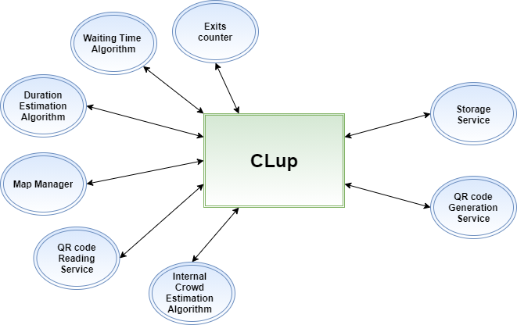

Figure 1: System Interfaces

In this description we will divide in two different types the external interfaces underlined in the picture above:

* First type (the system uses them to perform algorithmic operations):
  + **Duration Estimation Algorithm:** is used to estimate the duration of the visit of a long-term customer based on the duration of his previous visits. It needs to compute a large amount of data and estimates different duration for different day/time ranges.
  + **Waiting Time Algorithm:** is used to estimate the waiting time that a user has to wait before his turn. It uses estimations based on previous similar situations, same days of the week and same period.
  + **Map Manager:** is used to estimate the distance between the customers and the supermarkets. It computes the optimal path knowing the current state of all the streets of the city (work in progress streets, traffic jams, ...) and estimates the time needed to reach the supermarket from the current position of the device of the customer. It needs to be updated frequently and knows the real-time changes of the street situation.
  + **QR code Reading Service:** is used to read the QR code generated during the “LineUp” or “Book a Visit” request formulation. It is necessary to check if the current customer is one of the stored ones in the system that has made a request. It computes the visual reading of the QR code and sends to the system the information stored in it.
  + **Internal Crowd Estimation Algorithm:** is used to estimate, thanks to the list of the products chosen from the customer during the formulation of a “Book a visit” request, if it is possible to modify the maximum number of people inside the store without risks for the customers. If a person has to buy only products in a not-crowded section he notifies it to the system. For its correct functioning the algorithm needs the updated internal map of the supermarket and all the information about the shopping list of the customer. It has to implement geometric algorithms (like Binary Space Partitioning for example) for the correct estimate of the distribution in order to respect the “minimum distance” between people.
  + **Exits Counter:** is used to count how many customers left after they enter the supermarket in order to know how many customers are inside the store.
* Second type (the system has to rely on it):
  + **Storage Service:** is used to manage all the data useful for the system in order to achieve the goals presented in the previous section.
  + **QR code Generation Service:** is used to generate a unique QR code during the “LineUp” or “Book a Visit” request formulation. The QR code has to store in its structure a quite simple group of data (customer identifier, day, time, supermarket identifier).

2.1.2 Model Structure

The analysis of the system can now continue with the specification of the internal structure. The following diagram (Fig. 2) represents an high-level UML class diagram; it considers the most important objects and their relations with the final objective to reach the functionalities defined by goals described in the first section.

The main classes in the UML class diagram are:

* **Account**: represents the general user of the application. All the users need to provide a username and a password to identify themselves in the application. A user can be a Customer interested in access to the store or a Manager interested in controlling the influx of people.
* **Customer**: identifies a person who wants to buy something in the supermarket. He must provide his information to the system with a Login functionality. Then he chooses what service he wants to use between “Book a Visit” and “Line Up”. He must provide the correct position during the making of the request. Optionally the customer can also provide an email during the registration for the retrieval of lost password.
* **Manager:** identifies the administrator of the supermarket (or the administrator of a group of them). He must provide his information with a Login functionality and then he can change some parameters related to the maximum capacity of the supermarket in order to avoid crowds inside the store manually.
* **Supermarket:** identifies the supermarket that the customer has chosen for his requests. It contains all the information about the opening hour, the closing hour, the reference to its position, the product availability, the chain (if there is one) and the maximum capacity. It contains also the references to the two different types of requests “Book a Visit” and “LineUp” and the maximum capacity customers for both the services in order to avoid crowds inside the store.
* **Request:** represents the general request made by the user, each type of request requires some information related to the user identification, the supermarket chosen and a QR code for the access (generated from an external component, *QR code Generation Service*).
* **Book a visit Request:** specific request for the booking of a visit to the supermarket. It contains all the information about the specific time and date when the visit is booked. For the “duration” field it can be filled by the customer or generated by an external data analysis algorithm that estimates the time needed using the customer’s habits (*Duration Estimation Algorithm*). It can also contain a reference to the products that a person would buy or to generic categories of products, needed to help another external component (*Internal Crowd Estimation Algorithm*) to estimate the possible maximum capacity of the store in a specific moment avoiding the crowding of specific sectors in the supermarket.
* **Category:** represents the different categories in which every product of the supermarket is classified. In this way the *Internal Crowd Estimation Algorithm* can easily estimate where a person can move inside the building knowing his shopping list.
* **Product:** represents a specific product that a person would buy. It is useful also as a reminder if the customer uses the digital “shopping list”. Useful also for the *Internal Crowd Estimation Algorithm.*
* **Notification:** corresponds to a periodic notification sent to all the customers interested in this specific service provided by the application. It provides all the useful information to the customer about the day/time range when it is possible to “Book a visit” when the notification is generated.
* **Line Up Request:** specific request for the digital lining up functionality. It contains the identification number of the ticket (a sequential number), the estimated waiting time (thanks to the *Waiting Time Algorithm*) and the estimated time to reach the supermarket when a notification (for example: “Your turn is imminent!”) is shown in the application. It is possible to create a request also with a physical Ticket Machine placed outside the supermarket (to allow access to the supermarket to all the customers, also the ones without a digital device).
* **Ticket Machine:** corresponds to a physical machine placed outside the supermarket where it is possible to make simplified tickets only for the “Line Up” service. It needs only interaction with the Line Up functionality and has a very user-friendly interface.
* **Position:** stores the coordinates obtained by the GPS of the device in case of user interaction or the fixed coordinates corresponding to the position of a specific supermarket.
* **Street:** represents all the streets of a defined city, it is used for filtering all the possible supermarkets in the city using the application.
* **City:** represents the entire area of a defined city. Also this class is important to be considered as a filter in the functionalities of the system during the selection of a specific supermarket.

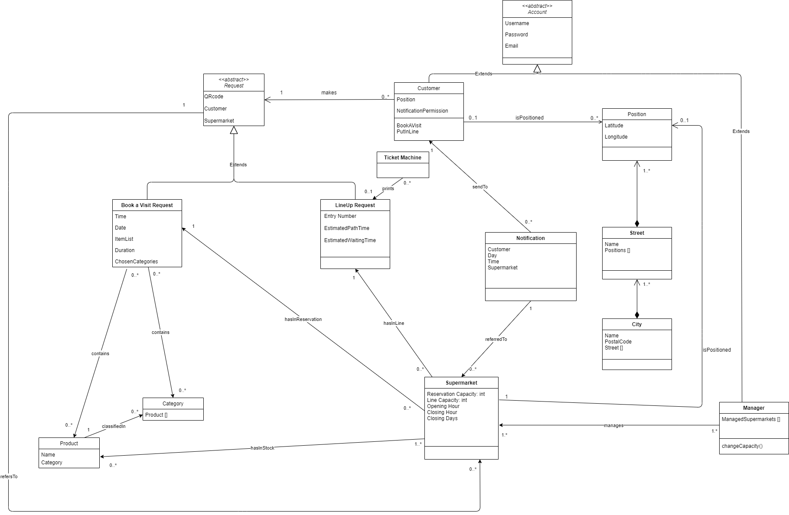

Figure 2: High-level UML class diagram

2.1.3 State Diagrams

Now we are going to analyse the main functionalities of the system in a dynamic situation, it is important to highlight the behaviour of a single object in response to a series of events in the system. We will use state diagrams to describe the most critical aspects of the objects previously described in the UML class diagram (Fig. 2).

**Line up**

This diagram starts with a “LineUp” request. It is important to remember that each request will be refused by the system if the requesting person is already in the queue.

The diagram (Fig. 3) starts when a notification is received in the unprocessed state. First the system checks if the user is already in the queue. If the answer is positive, the notification is rejected and the diagram ends, otherwise the system needs to store the user information and make some operations. The system puts the customer in the virtual line and then it needs to use the functionalities provided by the external services in order to calculate a reasonably precise estimation of the waiting time and the time needed to reach the store.

The “LineUp diagram” ends with the generation of the QR code and the communication to the customer that the request is successful.

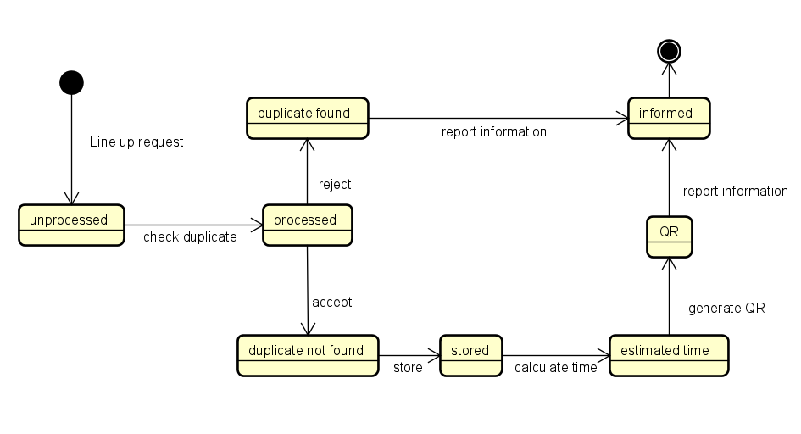

Figure 3: State Diagram “LineUp” request

**Duration**

In this diagram (Fig. 4) we want to highlight how the duration of the visit into the supermarket is checked. The diagram starts when a booking request is received. At first the system must check if the customer has inserted the approximate expected duration of the visit or not. If the answer is positive the request is stored.

If he is a long customer and the duration field is not inserted, the duration diagram continues with the estimation by the external service of a reasonable duration for the visit. It ends with the storing of all the information related to the booking request.

After that, the system will check if the store is fully booked and, if the answer is positive, further checks of the shopping list will be carried out (Fig. 5) otherwise the reservation will be stored and the ticket is generated.

In other cases the diagram terminates reporting the problem encountered.

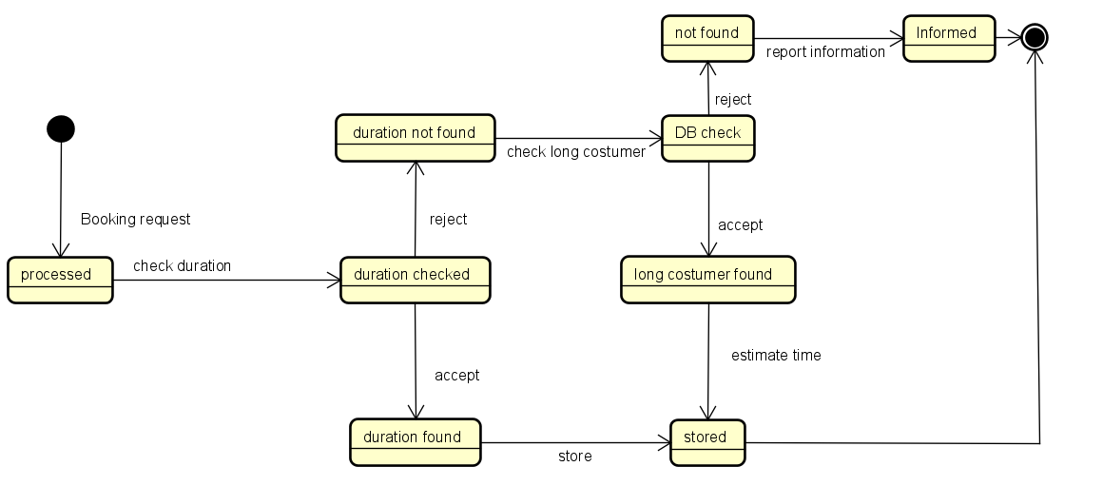

Figure 4: State Diagram Duration Checking

**Shopping List**

Shopping list is a quite complex functionality, for this reason we think it needs a state diagram to better understand how it works (Fig. 5). It is important to point out that the diagram only begins if there are no available reservation slots for “book a visit” functionality and this means also that the duration check was successful (Fig. 4).

At first the system checks if the customer has inserted the grocery list in order to understand if the internal departments he will visit will be crowded or not. If the customer has not inserted the shopping list the system informs the user and the diagram terminates.

Otherwise, if the departments are crowded the system will not be able to allow reservation, it will notify at first other available time slots in the same supermarket and then the supermarkets of the same chain that may still have free slots and the diagram terminates. Otherwise, in the case of departments not crowded, the system allows the reservation and the diagram terminates.

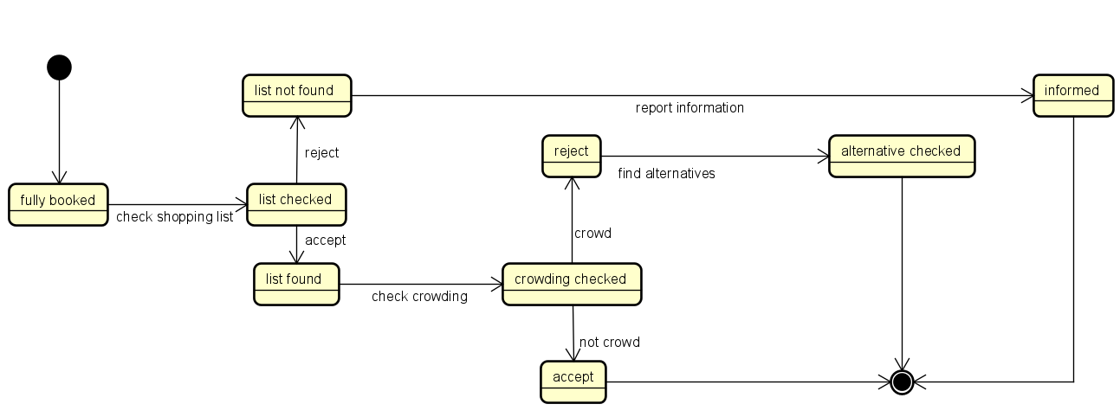

Figure 5: State Diagram Shopping List Checking

**Periodic Notifications**

This Notification diagram is important to better understand how notifications are managed (Fig. 6). This diagram will be repeated periodically by the system. It starts by scanning the list of users in the database, then for each customer the system checks whether it can send periodic notifications. If the answer is positive it checks if the customer has not received them recently and if he is also a long customer (we can know his preferred slot time and data )in that case, it will send a notification to the customer and the diagram terminates, in all other cases it ends without sending anything.

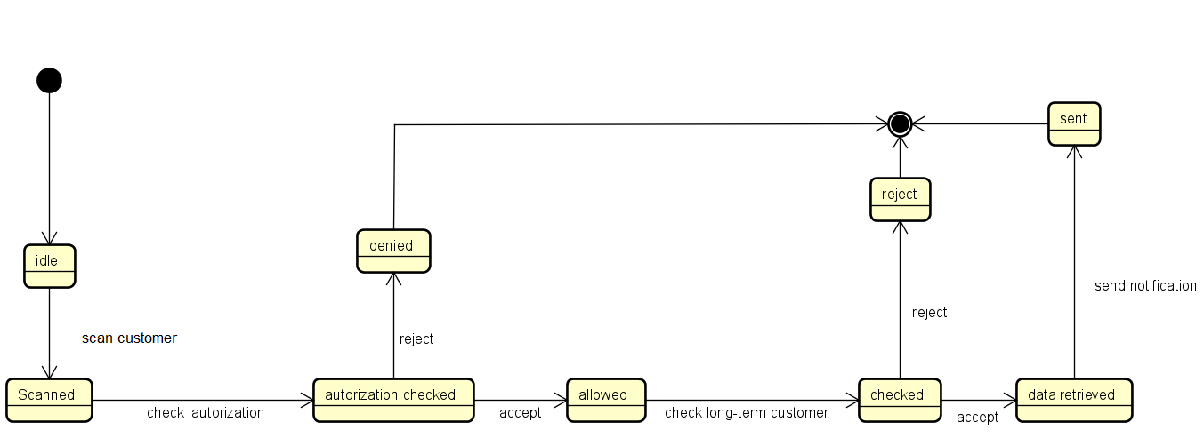

Figure 6: State Diagram Notification Authorization

2.2 Product Functions

In this subsection we are going to briefly discuss the main functions that the application should provide to the users. CLup is an application that mainly helps to limit the contagion between people by allowing them to do shopping in the supermarket in a safer way, but it also helps store managers to avoid creating crowds inside the store. In particular the customer can make two types of request: Line Up request and Book A Visit request, depending on if he wants to either get an online ticket in order to enter the store or make an online booking with also the selection of items. This application cannot check that people, who are inside the building, keep the right distance from each other, but it takes it for granted. Another function described is the Notification Function, in this case it is important to remark that this functionality is active only for users who have allowed notifications on their devices. The three functions described above are available only for customers and all of them require a login registration with username and password and an optional email to possibly restore a forgotten password. Whereas the Manager Function allows store managers to better manage people inside the building and monitor entrances, also in this case a manager must login and provide a supermarket identifier (or identifiers because he can also have more than one) that guarantees his authentication, with also a further OTP password.

2.2.1 Line Up Function

Customers are allowed to virtually line up through the application by means of a simple click. In this way, they can avoid physically waiting in front of the supermarket and eventually create crowds, which is not an ideal situation in this context. This function is granted only if the user has enabled the GPS on the device used. By choosing this functionality, the software must go through the following stages:

* Supermarket choice: The customer has to decide the supermarket in which he wants to go shopping, from a recommended list of the nearest ones based on his current position via GPS. If the preferred one is not in the list he can also insert it or filter the list by street or city.
* Duplicate check & storing: Before storing the request, the duplicate check is performed in order to prevent a request from a person who already has a ticket that has not yet been used. If no duplicate is found, the system stores the request.
* Time and Path calculation: In order to guide the customer to reach the store, it uses the Map Manager to estimate the time needed from the current position of the customer device to reach the store. The customer is supposed to follow the shortest path, otherwise, if he were too early or too late, it could still create crowds at the entrance which does not ensure compliance with the safety distance.
* Ticket release: At the end the system generates the QR Code, by using the QR Code Generation Service, that the customer has to scan at the entrance to the supermarket in order to go in. Moreover the customer is provided with a unique number which represents his turn and with an estimation of the waiting time by using Waiting Time Algorithm so he can get an idea on when to go out.

All the shops are supposed to have a Ticket Machine at the entrance, this allows people also to “hand out” a physical ticket without using the application on their devices. These tickets are considered as Line Up tickets by the system.

2.2.2 Book a Visit Function

The application also offers the possibility to book a visit to go to the store, in order to plan doing shopping in a more technological way also by selecting items that the customer wants to buy. The system ensures that anyone who makes a reservation request for a certain date and at a certain time does not have to wait for entering because the store certainly has not reached the maximum number of people. This means that, in the meantime from the booking time to the actual visiting time, there cannot be a number of line up requests that have determined the filling of the store. This because the system divides the maximum store capacity into two sub-capacities, one relating only to the line up request and the other to the booking requests, in this way there are no conflicts. After having clicked on this feature, the customer can fill the request by the following steps:

* Supermarket choice: the customer has to decide in which supermarket to make the booking. This selection is done exactly as in Line Up Function and during the filling of the request the customer can always change his selection.
* Slot selection: the customer must select date and time of the booking, the system suggests available free slots to simplify the choice. This field is mandatory.
* Items selection: at this point customer can select which product to choose from a list, or he can also choose only categories. We have assumed that all the products on the list are available, in such a way there is no possibility that a person who goes to the supermarket does not find any of the pre-selected products. This field is not mandatory, but if inserted it allows the system to better manage internal departments of the store, in fact if two persons purchase different products the system can decide to allow more people even if the shop is already full, by applying Internal Crowd Estimation Algorithm.
* Duration estimation: the customer can also insert an estimation time of the visit duration. This field is mandatory for non-long-term customers, on the other side is optional for long-term ones, indeed in this case the duration can be inferred by the system itself depending on his previous visits by applying Duration Estimation Algorithm.

2.2.2.1 Suggested Alternatives Function

When the Book A Visit request is sent, if the selected date and time slot is not available, the system suggests some alternatives to facilitate the customer choice: in particular if the customer has inserted the list of items he wants to purchase, the system informs him that the store is fully booked at that time and it advises him to change slot or also to change supermarket, if all the available suggested slots are not what the customer wants (Fig. 19); otherwise, if the customer has not inserted his shopping list, the system gives him the possibility to change slot (or also supermarket as in the previous case) or to insert the shopping list, in such a way the system maybe can allow the customer to go even if the store is full if the request passes the crowding check based on his items selection as shown in the Mockup (Fig. 17).

2.2.2.2 Notification Function

This function is an additional feature that allows customers to periodically be informed regarding free slots, in terms of date and time, of a particular store. It is optional because the customer can decide whether to turn it on or not, but if active, it requires the customer's device to have active notifications. Once activated, it can be deactivated again. The system generates and sends notifications depending on data stored in the system: for instance if a customer usually goes to do shopping on a certain day, the system knows this and it notifies the best time to go to the store in which maybe it is not too crowded.

2.2.3 Manager Function

A store manager is a particular user that cannot make requests, indeed his application interface is different and includes:

* the supermarket he runs: he can have even more than one and he can also have the option of adding others or deleting one existing.
* number of allowed persons: he can decide how many people are allowed at the same time in the store, he can also change this number in order to manage entrances. He communicates with the machine at the entrance that scans QR codes, in this way when he changes the number, the machine is updated and if needed he stops to scan tickets until at least one person has exited.

2.3 User Characteristics

In this section we want to specify in a more detailed way users characteristics. We have identified two types of User, based on different requests that can make: typical Customers that is a general client of the application and store Managers, they interact with CLup through different interfaces. It’s important to remark that also Ticket Machine can be considered as a special User, indeed, by releasing physical tickets at the store entrances, it interacts with the system sending Line Up requests, even if it has no username or password.

* **Customer:**
  + Must have a device to login to CLup.
  + Must login with username, password and an optional email and always inserts correct data while registering.
  + Must enable the GPS in his device.
  + Can make a Line Up request, by choosing the supermarket.
  + Can make a Book A Visit request, by choosing the supermarket, date and time, the list of items and the duration of the visit.
  + Can be informed about other options of different supermarkets.
  + Can retrieve QR code and a ticket number.
  + Can turn on periodic notifications to be informed about available free slots to go to the store.
  + Is supposed to always follow the shortest path from the current position to the store.
* **Manager:**
  + Must login through a web interface with username, password and email.
  + Must insert an OTP sent by the system and a unique identifier of the store in order to be recognized.
  + Can manage one or more supermarkets.
  + Must decide the number of allowed people in the stores.
  + Can change the number of allowed people in the store.

2.4 Domain Assumptions

Domain properties are descriptive assertions assumed to holdin the world in order to better explain properties that cannot be controlled by the system itself. They are useful to describe the world in which CLup works and they help to accomplish the goals described in Section 1.3.1 together with the functional requirements, described later on Section 3.2.1.

**DA1:** Customers always insert correct data while registering to CLup.

**DA2:** If a user makes a reservation he effectively goes to the supermarket in time.

**DA3:** Users must follow the shortest path to the shop.

**DA4:** The devices used have date and time working properly.

**DA5:** Internet connection works always without errors.

**DA6:** QR code is always readable.

**DA7:** Maps of Italy are well known, complete and up to date.

**DA8:** Product disposition inside the shops is always known.

**DA9:** Users must buy what they previously have selected.

**DA10:** Opening and closing hours of the shops are always known.

**DA11:** Two persons in the shop always keep distance of at least one meter.

**DA12:** All shops have a unique identifier.

**DA13:** The number of people permitted by law in the shops is known.

**DA14:** Estimated time from one place to another is always correct.

**DA15:** Estimated time of a person in a shop is always what he has previously inserted.

**DA16:** Estimated time of a long-term customer is always correct.

**DA17:** All users have devices’ notifications up and running.

**DA18:** All shops have a ticket release machine at the entrance.

**DA19:** All shops have a ticket QR code reading machine (or something similar) at the entrance, in order to read the tickets.

**DA20:** All items selectable in the application are always available in the shop.

**DA21:** The system knows all the positions of supermarkets.

**DA22:** The GPS module of the devices on which CLup runs always works correctly and has an accuracy of 2 meters.

**DA23:** All shops have a sensor (or something similar) that takes into account customers’ exits.

2.5 The World and the Machine

Now we are going to point out the world and shared phenomena of CLup. The world is the environment, the partition of the reality affected by machines including stakeholders and any external system. The machine is the system we must develop. Therefore, shared phenomena are phenomena controlled by the world and observed by the machine and vice-versa.

|  |  |
| --- | --- |
| **N°** | **WORLD PHENOMENA** |
| **WP1** | No queue outside the supermarket. |
| **WP2** | Situation of necessity for which it is necessary to regulate the number of people. |
| **WP3** | The customer goes to the shop. |

Table 1:World Phenomena

|  |  |
| --- | --- |
| **N°** | **SHARED PHENOMENA** |
| **SP1** | The customer accesses the application. |
| **SP2** | The manager accesses the application. |
| **SP3** | The customer makes a booking request. |
| **SP4** | The customer makes a line up request. |
| **SP5** | The customer looks for available supermarkets. |
| **SP6** | The manager regulates internal capacity. |
| **SP7** | The customer scans the ticket upon entering. |

Table 2:Shared Phenomena

**3 Specific Require****ments**

This section is important to better explain all the requirements needed by our system in order to work properly and achieve all the goals previously described.

3.1 External Interface Requirements

3.1.1 User Interfaces

In the following section is possible to take a look at the mockups of the most important parts of the application. A more detailed analysis of them is provided in the Design Document and also a chart showing how the different screenshots are linked together. This brief preview is shown in order to fully understand how the different functionalities required by the goals (Section 1.3.1) are reached and how the users interact with the system in the Use Cases of the following section (Section 3.3.3).

In the first part are shown the screenshots for the “Line Up” functionality, then are presented the screenshots of the “Book a Visit” functionality and in the end are presented the Ticket Machine interface and the “Manager” functionality used by the Supermarket’s Manager.

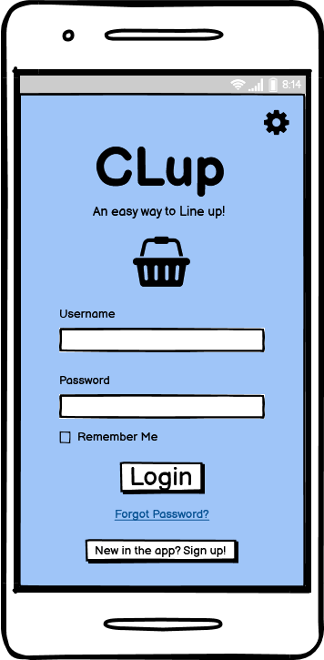 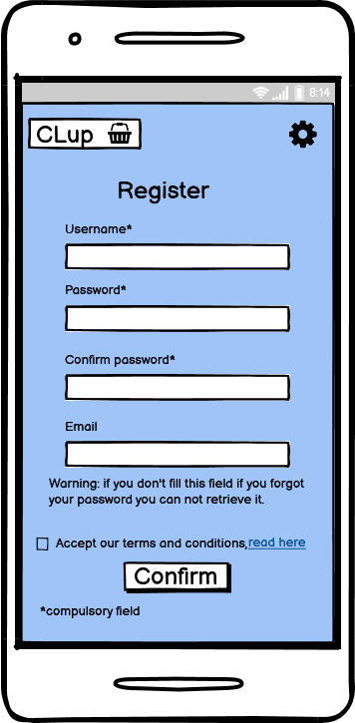

Figure 7: Login Customer Figure 8: Registration Customer

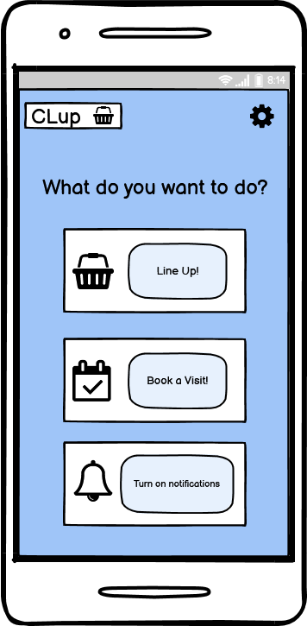 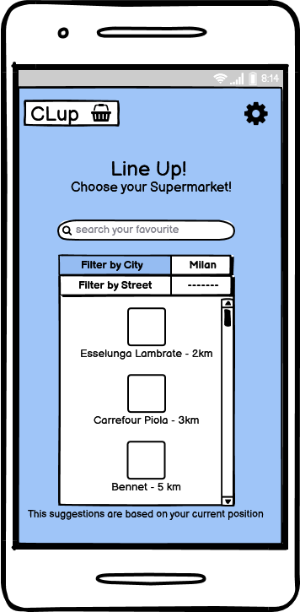

Figure 9: Home Page Figure 10: Choice of Supermarket (LineUp)

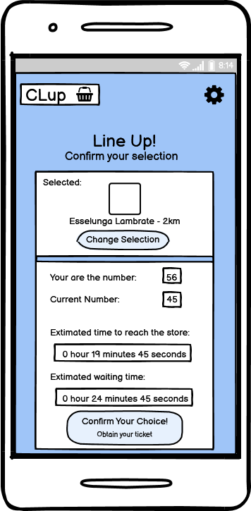 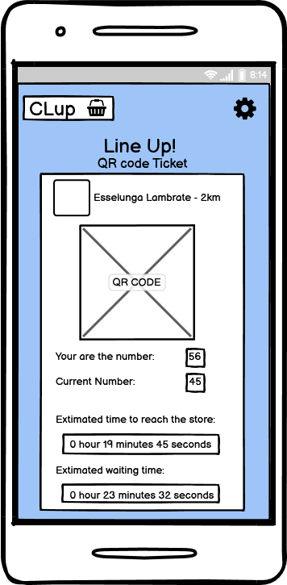

Figure 11: Ticket Preview (LineUp) Figure 12: Ticket (LineUp)

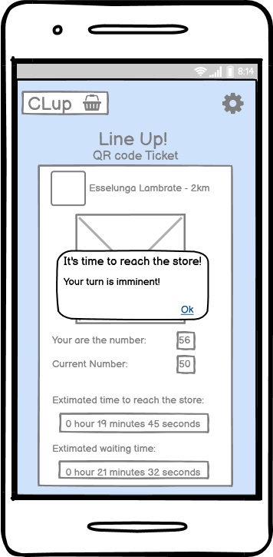 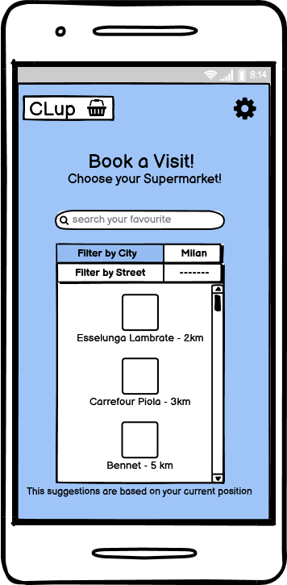

Figure 13: Ticket Notification (L-Up) Figure 14: Choice of Supermarket (B-Visit)

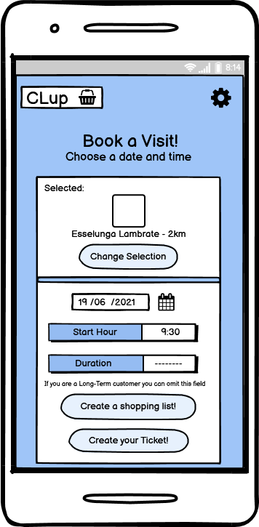 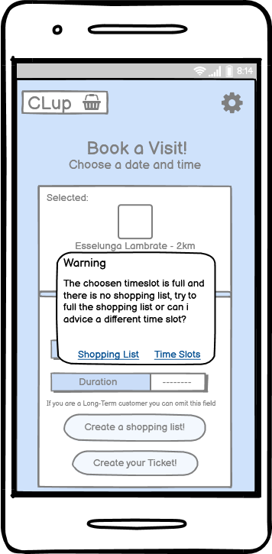

Figure 15: Time Slot Choice (B-Visit) Figure 16: Fully Booked Notification (B-Visit)

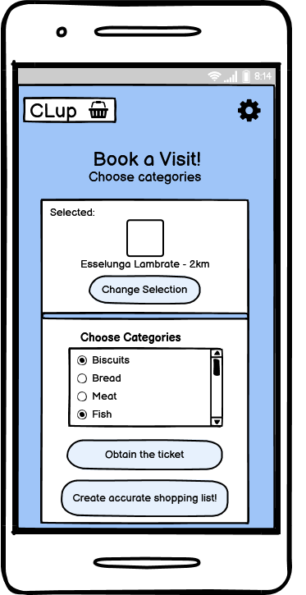 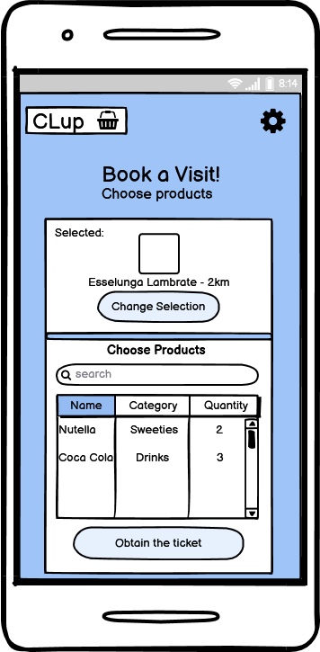

Figure 17: Choice of Product Categories Figure 18: Shopping List

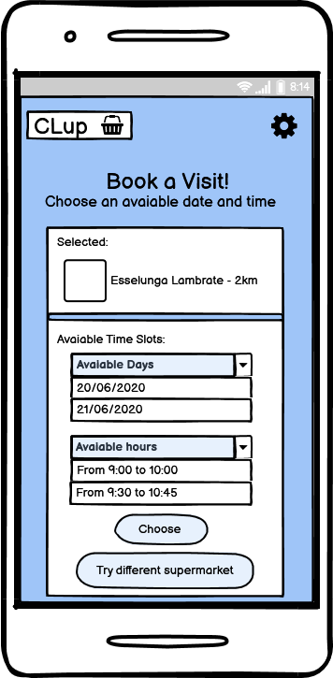 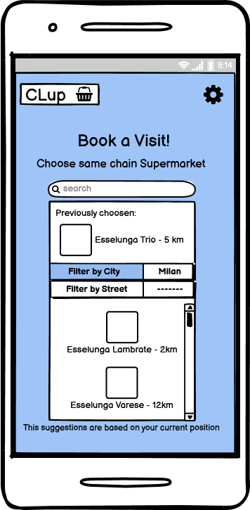

Figure 19: Suggested Time Slots Figure 20: Alternative Stores

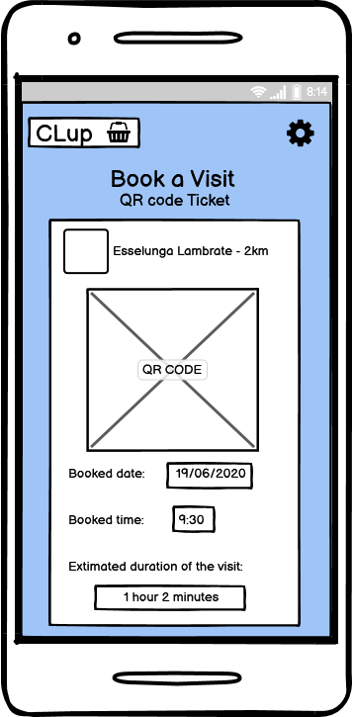 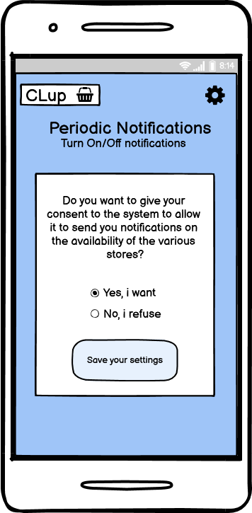

Figure 21: Ticket (B-Visit) Figure 22: Notification Management

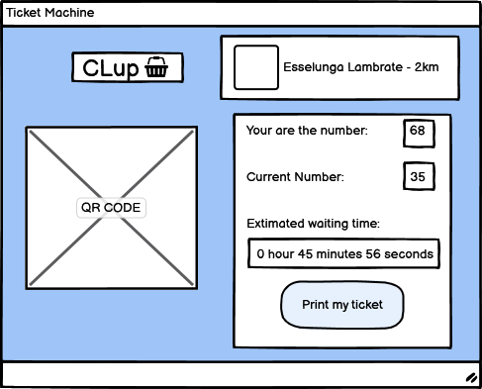

Figure 23: Ticket Machine (LineUp)

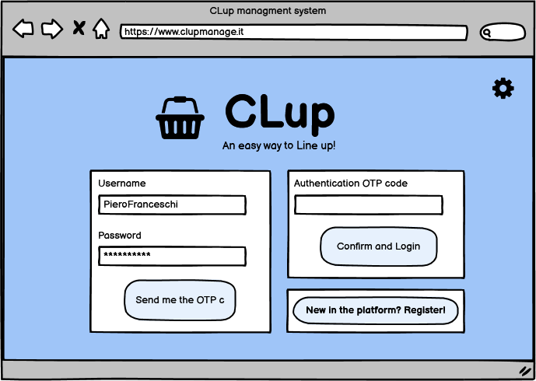

Figure 24: Login Page Manager

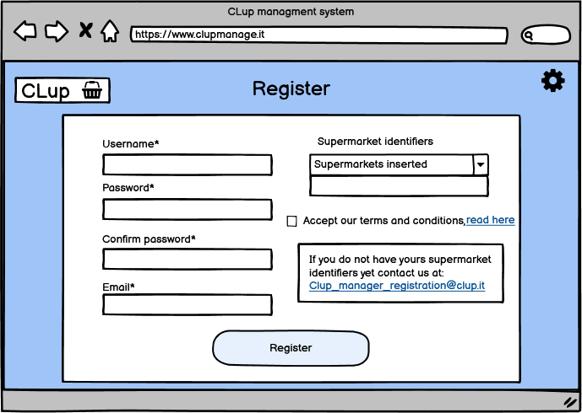

Figure 25: Registration Page Manager

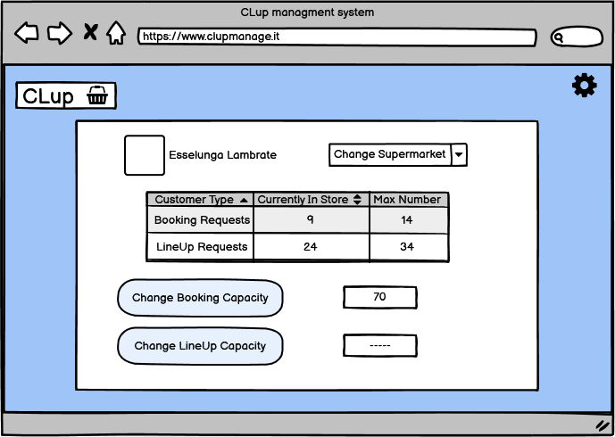

Figure 26: Home Page Manager

3.1.2 Hardware Interfaces

The interfaces needed by the system for its correct functioning are the ones related to the customer device, in particolar the access to the notification system of the device in order to send the periodic notifications of the “Notification Function” (Section 2.2.2.2) and the access to the GPS system for the geo-localization of the device during the creation of a “Book a Visit” request or a “Line Up” request (respectively Sections 2.2.2 - 2.2.1) in order to obtain the correct estimated time needed to reach the store.

3.1.3 Software Interfaces

Software interfaces are related to the external services needed by the application for his functioning. A small analysis of what are and why are important is reported in Section 2.1.1 and fully described in the Design Document. The system needs to interact with different services and for this reason has different interfaces. The application does not provide API for other external applications.

3.1.4 Communication Interfaces

A fundamental aspect to take into account while the development of the system is the fact that the customer application and the central system needs to communicate in real time for the management of the different requests and the update of the user interface. So we can expect from this specification a system capable of receiving multiple requests and managing all of them communicating in different ways for the different services to be guaranteed to the customer.

3.2 Functional Requirements

In this subsection we give a complete list of the functional requirements of our system and then we specify the mapping among **Goals, Requirements** and **Domain Assumption.**

3.2.1 Requirements

**R1:** The system must allow customers to register.

**R2:** The system must allow managers to register.

**R3:** The system must allow customers to log in.

**R4:** The system must allow managers to log in.

**R5:** The system must guarantee that each username is unique.

**R6:** The system must save customers registration data.

**R7:** The system must prevent users from using special characters in their username.

**R8:** The system must retrieve the GPS position while the user makes a reservation.

**R9:** The system must allow users to insert in which store they want to go.

**R10:**  The system must allow users to insert a shopping list of items available in the store.

**R11:** The system must allow users to choose categories of products.

**R12:** The system must provide users with the QR code.

**R13:** The system must provide users with the ticket number.

**R14:** The system must allow users to insert visit date on the booking.

**R15:** The system must allow users to insert visit time on the booking.

**R16:** The system must be able to send notifications to the user.

**R17:** The system must allow customers to filter by city.

**R18:** The system must allow customers to filter by street.

**R19:** The system must estimate the waiting time before customers’ turn.

**R20:** The system must infer the usual duration of the visit to the store of a long-term customer.

**R21:** The system must estimate the necessary time to arrive at the store.

**R22:** The system must notify users in advance about their turns.

**R23:** The system must allow users to indicate the approximate expected duration of the visit.

**R24:** The system must allow managers to know how many “line up customers“ are inside.

**R25:** The system must allow managers to know how many “book a visit customers” are inside the shop.

**R26:** The system must allow managers to add a shop in the managed ones.

**R27:** The system must allow managers to remove a shop in the managed ones.

**R28:** The system must allow managers to change the maximum booking capacity of the managed shops.

**R29:** The system must allow managers to change the maximum line up capacity of the managed shops.

**R30:** The system must allow customers to be informed about the availability of different time slots.

**R31:** The system must allow customers to be informed about the availability of different supermarkets of the same chain.

**R32:** The system must allow customers to know if the store is in one of its closing days or not.

**R33:** The system must save managers registration data.

3.2.2 Goals Mapping

|  |  |  |
| --- | --- | --- |
| **GOALS** | **REQUIREMENTS** | **DOMAIN ASSUMPTIONS** |
| G1 | R1, R3, R5, R6, R8, R9, R12, R13, R17, R18, R19, R21, R22 | DA1, DA2, DA3, DA4, DA5, DA6, DA7, DA10, DA11, DA13, DA14, DA18, DA19, DA21, DA22, DA23 |
| G2 | R2, R4, R5, R7, R24, R25, R26, R27, R28, R29, R33 | DA5, DA10, DA11, DA13, DA15, DA16, DA19, DA20, DA21, DA22, DA23 |
| G3 | R1, R3, R5, R6, R7, R8, R9, R10, R11, R12, R14, R15, R17, R18, R19, R20, R23, R32 | DA1, DA2, DA4, DA5, DA6, DA7, DA8, DA9, DA10, DA11, DA13, DA15, DA16, DA19, DA20, DA21, DA22 |
| G4A | R1, R3, R5, R6, R7, R8, R9, R14, R15, R30, R32 | DA4, DA5, DA10, DA11, DA13 |
| G4B | R1, R3, R5, R6, R7, R8, R9, R17, R18, R31, R32 | DA1, DA4, DA5, DA7, DA10, DA13, DA21, DA22 |
| G2C | R1, R3, R5, R6, R7, R9, R16, R17, R18, R32 | DA1, DA4, DA5, DA10, DA13, DA17, DA21, DA22 |

Table 3: Goals mapping

**G1**: Users should be able to virtually line up through the app to enter the store.

**R1** The system must allow customers to register.

**R3** The system must allow customers to log in.

**R5** The system must guarantee that each username is unique.

**R6** The system must save customers registration data.

**R7** The system must prevent users from using special characters in their username.

**R8** The system must retrieve the GPS position while the user makes a reservation.

**R9** The system must allow users to insert in which store they want to go.

**R12** The system must provide users with the QR code.

**R13** The system must provide users with the ticket number.

**R17** The system must allow customers to filter by city.

**R18** The system must allow customers to filter by street.

**R19** The system must estimate the waiting time before customers’ turn.

**R21** The system must estimate the necessary time to arrive at the store.

**R22** The system must inform users in advance about their turns.

**DA1**  Customers always insert correct data while registering to CLup.

**DA2**  If a user makes a request he effectively goes to the supermarket in time.

**DA3**  Users must follow the shortest path to the shop.

**DA4**  The devices used have date and time working properly.

**DA5**  Internet connection works always without errors.

**DA6**  QR is always readable.

**DA7** Maps of Italy are well known, complete and up to date.

**DA10**  Opening and closing hours of the shops are always known.

**DA11**  Two persons in the shop always keep distance of at least one meter.

**DA13** The number of people permitted by law in the shops is known.

**DA14** Estimated time from one place to another is always correct.

**DA18** All shops have a ticket release machine at the entrance.

**DA19** All shops have a ticket QR code reading machine (or something similar) at the entrance, in order to read the tickets.

**DA21** The system knows all the positions of supermarkets.

**DA22** The GPS module of the devices on which CLup runs always works correctly and has an accuracy of 2 meters.

**DA23** All shops have a sensor (or something similar) that takes into account customers’ exits.

**G2**: Store managers should be able to regulate the influx of people inside the building.

**R2** The system must allow managers to register.

**R4** The system must allow managers to log in.

**R5** The system must guarantee that each username is unique.

**R7** The system must prevent users from using special characters in their username.

**R24** The system must allow managers to know how many “line up customers“ are inside.

**R25** The system must allow managers to know how many “book a visit customers” are inside the shop.

**R26** The system must allow managers to add a shop in the managed ones.

**R27** The system must allow managers to remove a shop in the managed ones.

**R28** The system must allow managers to change the maximum booking capacity of the managed shops.

**R29** The system must allow managers to change the maximum line up capacity of the managed shops.

**R33** The system must save managers registration data.

**DA5** Internet connection works always without errors.

**DA10**  Opening and closing hours of the shop are always known.

**DA11** Two persons in the shop always keep distance of at least one meter.

**DA12** All shops have a unique identifier.

**DA13** The number of people permitted by law in the shop is known.

**DA19** All shops have a ticket QR code reading machine (or something similar) at the entrance, in order to read the tickets.

**DA23** All shops have a sensor (or something similar) that takes into account customers’ exits.

**G3**: Users should be able to “book a visit” to the supermarket in order to go shopping.

**R1** The system must allow customers to register.

**R3** The system must allow customers to log in.

**R5** The system must guarantee that each username is unique.

**R6** The system must save customers registration data.

**R7** The system must prevent users from using special characters in their username.

**R8** The system must retrieve the GPS position while the user makes a reservation.

**R9** The system must allow users to insert in which store they want to go.

**R10** The system must allow users to insert a shopping list of items available in the store.

**R11** The system must allow users to choose categories of products.

**R12** The system must provide users the QR code.

**R14** The system must allow users to insert visit date on the booking.

**R15** The system must allow users to insert visit time on the booking.

**R17** The system must allow customers to filter by city.

**R18** The system must allow customers to filter by street.

**R20** The system must infer the usual duration of the visit on the store of a long-term customer.

**R23** The system must allow users to indicate the approximate expected duration of the visit.

**R32** The system must allow customers to know if the store is in one of its closing days or not.

**DA1** Customers always insert correct data while registering to CLup.

**DA2** If a user makes a reservation he effectively goes to the supermarket in time.

**DA4** The devices used have date and time working properly.

**DA5** Internet connection works always without errors.

**DA6** QR is always readable.

**DA7** Maps of Italy are well known, complete and up to date.

**DA8** Product disposition inside the shop is always known by the system.

**DA9** Users must buy what they previously have selected.

**DA10**  Opening and closing hours of the shops are always known.

**DA11** Two persons in the shop always keep distance of at least one meter.

**DA13** The number of people permitted by law in the shops is known.

**DA15** Estimated time of a person in a shop is always what he has previously inserted.

**DA16** Estimated time of a long-term customer is always correct.

**DA19** All shops have a ticket QR code reading machine (or something similar) at the entrance, in order to read the tickets.

**DA20** All items selectable in the application are always available in the shop.

**DA21** The system knows all the positions of supermarkets.

**DA22** The GPS module of the devices on which CLup runs always works correctly and has an accuracy of 2 meters.

**DA23** All shops have a sensor (or something similar) that takes into account customers’ exits.

**G4**: Users should be able to know different alternatives and suggestions.

**G4A**: Users should be able to know alternative time slots for visiting the store, during the booking, if the preferred one is not available.

**R1** The system must allow customers to register.

**R3** The system must allow customers to log in.

**R5** The system must guarantee that each username is unique.

**R6** The system must save customers registration data.

**R7** The system must prevent users from using special characters in their username.

**R8** The system must retrieve the GPS position while the user makes a reservation.

**R9** The system must allow users to insert in which store they want to go.

**R14** The system must allow users to insert visit date on the booking.

**R15** The system must allow users to insert visit time on the booking.

**R30** The system must allow customers to be informed about the availability of different time slots.

**R32** The system must allow customers to know if the store is in one of its closing days or not.

**DA4** The devices used have date and time working properly.

**DA5** Internet connection works always without errors.

**DA10**  Opening and closing hours of the shop are always known.

**DA11** Two persons in the shop always keep distance of at least one meter.

**DA13** The number of people permitted by law in the shop is known.

**G4B**: Users should be able to know different stores of the same chain if the preferred one is not available.

**R1** The system must allow customers to register.

**R3** The system must allow customers to log in.

**R5** The system must guarantee that each username is unique.

**R6** The system must save customers registration data.

**R7** The system must prevent users from using special characters in their username.

**R8** The system must retrieve the GPS position while the user makes a reservation.

**R9** The system must allow users to insert in which store they want to go.

**R17** The system must allow customers to filter by city.

**R18** The system must allow customers to filter by street.

**R31** The system must allow customers to be informed about the availability of different supermarkets of the same chain.

**R32** The system must allow customers to know if the store is in one of its closing days or not.

**DA1** Customers always insert correct data while registering to CLup.

**DA4** The devices used have date and time working properly.

**DA5** Internet connection works always without errors.

**DA7** Maps of Italy are well known, complete and up to date.

**DA10**  Opening and closing hours of the shops are always known.

**DA13** The number of people permitted by law in the shops is known.

**DA21** The system knows all the positions of supermarkets.

**DA22** The GPS module of the devices on which CLup runs always works correctly and has an accuracy of 2 meters.

**G4C**: Users should be periodically informed about different free day/time slots for visiting the store.

**R1** The system must allow customers to register.

**R3** The system must allow customers to log in.

**R5** The system must guarantee that each username is unique.

**R6** The system must save customers registration data.

**R7** The system must prevent users from using special characters in their username.

**R9** The system must allow users to insert in which store they want to go.

**R16** The system must be able to send notifications to the user.

**R17** The system must allow customers to filter by city.

**R18** The system must allow customers to filter by street.

**R32** The system must allow customers to know if the store is in one of its closing days or not.

**DA1** Customers always insert correct data while registering to CLup.

**DA4** The devices used have date and time working properly.

**DA5** Internet connection works always without errors.

**DA10**  Opening and closing hours of the shop are always known.

**DA13** The number of people permitted by law in the shop is known.

**DA17** All users have devices’ notifications up and running.

**DA21** The system knows all the positions of supermarkets.

**DA22** The GPS module of the devices on which CLup runs always works correctly and has an accuracy of 2 meters.

3.3 Use Cases Identification

In this section we illustrate Scenarios, Use Case Diagram and Use Case Description. We have divided them based on whether they refer to customers or managers, in this way the functionalities each one refers to, are more readable. Each Use Case Description has its own Sequence Diagram which explicits a dynamic view of messages exchanged. At the end there is the Traceability Matrix which helps to better understand correspondence between Use Cases and Requirements through proper identifiers.

3.3.1 Scenarios

Here we are going to identify some scenarios for the Customer and for the Manager. Scenarios are a concrete, focused, informal description of a single feature of the system to be with the aim of better understanding how CLup works and how it can be useful in some events of real life.

**Customer**

**CS1:**  Franco is an engineer and he has a very busy life due to his work. He does not have enough time to spend at the supermarket to do shopping. In this context CLup booking feature is very useful because it allows him to plan shopping by choosing the list of items on the application. Moreover he does not need to go around the store and then maybe discover that the item he is looking for is not really there because the app only shows items that are available in the store. In this way CLup offers him the comfort of going to the shop, avoiding waiting to enter, going directly to the relevant departments of the store and finally he can exit with the minimum time spent. All this and moreover in a safe way to avoid contagion!

**CS2:** An 84-year-old elderly lady named Anna lives alone in Milan. She has two adult children who no longer live in her same house. Despite her age, she is an independent lady and does not need any help. Therefore everything she does, she does it herself and without help, including going to the grocery store when she needs it but in this dangerous situation, due to the virus, is a risk. CLup also allows elderly people, who do not have access to technology, to deal with its features, indeed Anna can go to the store and get her physical ticket from the Ticket Machine at the entrance. In this way, she will be able to do shopping in a safer way without taking too many risks.

**CS3:** Marco is an off-site master’s degree student at the Politecnico di Milano and during the week he has very uncomfortable lesson times from Monday to Friday, he also enrolled in an extracurricular course and keeps him busy even on Saturdays. The only free day of the week is Sunday and on which he can go to the shop, since in this situation, it is the only allowed way to relax and free his mind. From this point of view he uses CLup which knows from data stored that Marco does shopping always on Sundays and every week it suggests the best time to go to the store on Sunday of that week in order to find it not too crowded.

**CS4:** Valeria is a girl who works as an assistant cook in a retirement home and needs to go out to buy pasta in a grocery store because it is running out. Even though she is a young girl, she cannot afford to expose herself to the virus because of the people she is in contact with. A friend advises her to register on CLup and use LineUp function, in such a way Valeria can wait her turn without going out and without being in direct contact with too many people.

**CS5:** Luca is a young wedding planner and his work reflects very well how he is in his life, in fact he is a perfectionist, an organized guy. He loves to plan his life as well as weddings. This week he had planned to go shopping Wednesday afternoon at 5pm, but strangely he forgot to book. So he tries to book by using CLup, but unfortunately the store is full at that time. Through to the advanced functionality of CLup, he is informed about other near supermarkets. Therefore thanks CLup he discovers a new near supermarket and in addition to that, he does not have to change slot time to do shopping, which would have been a very unpleasant event for all his future plans!

**Manager:**

**MS1:** Guido runs a Carrefour near Lambrate and he uses CLup to better manage his store. Due to the worsening of the Covid19 situation, The Prime Minister issues a new DPCM according to which Lombardy becomes a red zone, this implies new strong restrictions in the region. In response to this, Guido decides to safeguard people who go to his shop by decreasing the number of allowed people in the building. He can do this through the CLup Web Interface.

3.3.2 Use Case Diagram

The following picture (Fig. 27) represents a Use Case Diagram that shows how actors are involved in Use Cases and how Use Cases are linked to each other. In addition to that, the picture highlights all the functionalities provided by the system.

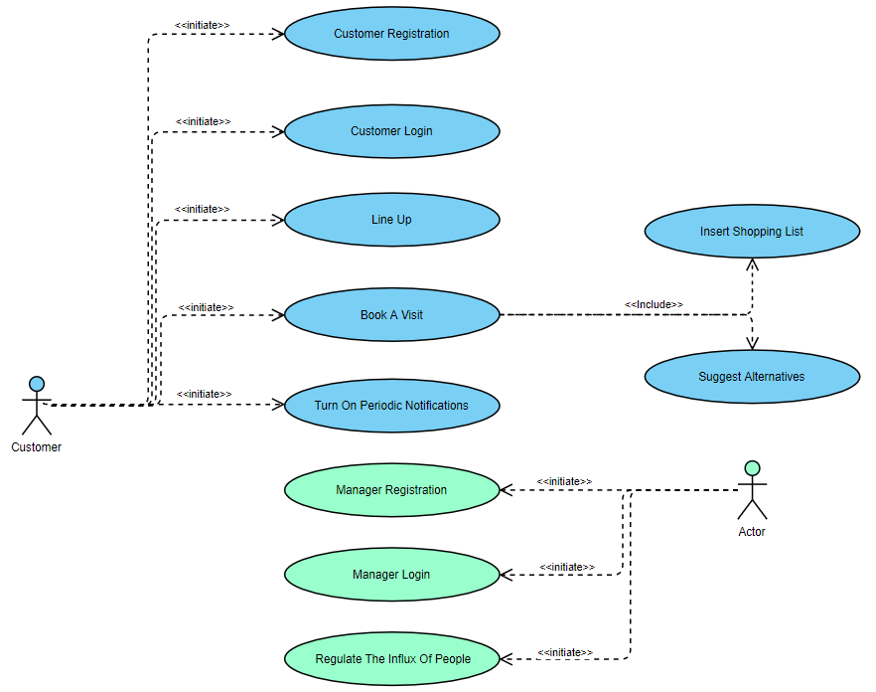

Figure 27: Use Case Diagram

3.3.3 Use Cases Description

**Customer**

UCD1 Customer Registration:

|  |  |
| --- | --- |
| Name | Customer Registration |
| Actors | Customer |
| Entry Condition | The customer has started CLup on his device |
| Flow of events | 1. The customer clicks on sign up button 2. The customer chooses a username and a password 3. The customer confirms his password 4. The customer optionally inserts his email 5. The customer accepts the Terms and Conditions of CLup 6. The customer clicks on confirm button 7. The system checks the username to be unique 8. The system checks the email 9. The system stores the customer data |
| Exit Condition | The customer is registered in the system |
| Exception | * If the confirmed password is not the same as the first one, the system informs the customer that the two passwords are different. * If the username inserted by the user is already used by another user, or if the username contains any special character, the system displays an error message asking the user to insert a different one. * If the email is inserted and the system finds a duplicate it rejects the request. |

Table 4: *Customer Registration* Use Case Description

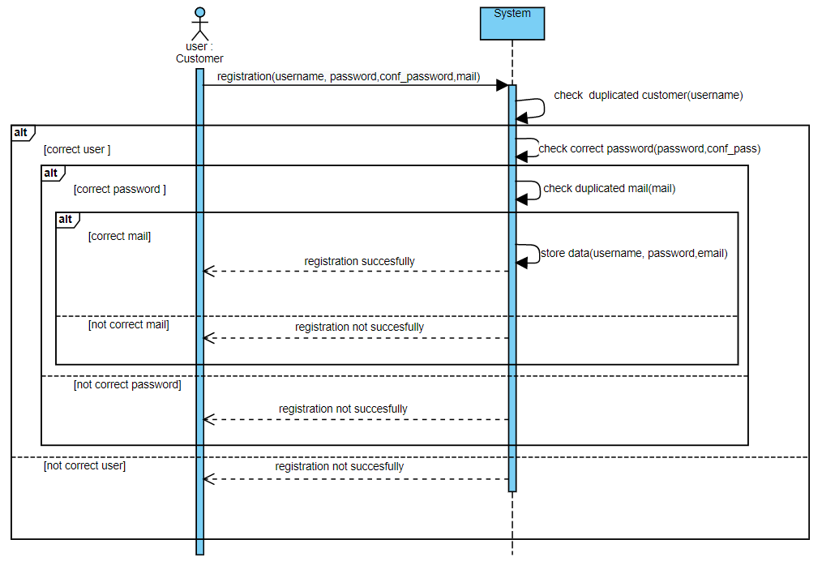

Figure 28: *Customer Registration* Sequence Diagram

UCD2 Customer Login:

|  |  |
| --- | --- |
| Name | Customer Login |
| Actors | Customer |
| Entry Condition | The customer has started CLup on his device |
| Flow of events | 1. The customer inserts his username 2. The customer inserts his password 3. The customer optionally clicks on ‘Remember me’ 4. The customer clicks on ‘Login’ 5. The system checks the username to be existing 6. The system checks the password to be correct |
| Exit Condition | The customer is logged in |
| Exceptions | * If the system does not recognize the username inserted, the customer is not registered yet, or the username is incorrect. The system informs the customer about this. * If the password is incorrect, the system informs the customer to reinsert it. If he wrongs again, the system suggests the customer to reset a new password by sending him an email. |

Table 5: *Customer Login* Use Case Description

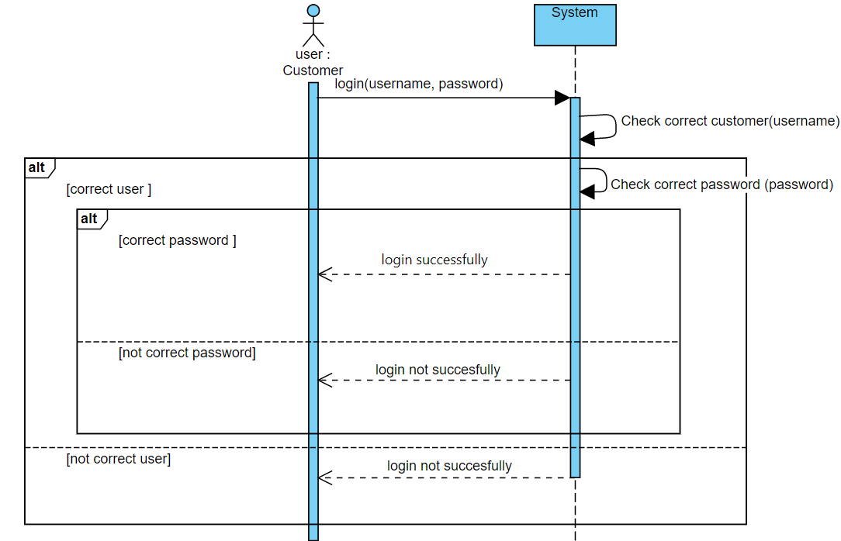

Figure 29: *Customer Login* Sequence Diagram

UCD3 Line Up:

|  |  |
| --- | --- |
| Name | Line Up |
| Actors | Customer |
| Entry Condition | The customer is logged in |
| Flow of events | 1. The customer clicks on ‘Line Up!’ 2. The system retrieves GPS position of the customer device 3. The customer selects supermarket from a list 4. The system checks duplicate requests 5. The system stores the request 6. The system estimates time to reac 7. The system estimates waiting time 8. The system generates QR code 9. The system generates ticket number 10. The system return the ticket |
| Exit Condition | QR code ticket for line up is shown to the customer |
| Exceptions | * If the system finds more than one duplicate request, it rejects the request. |

Table 6: *Line Up Function* Use Case Description

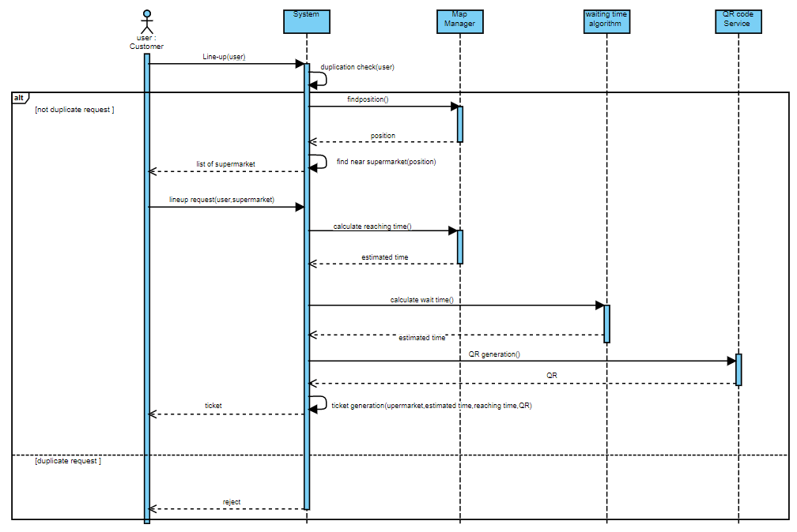

Figure 30: *Line Up Function* Sequence Diagram

UCD4 Book A Visit:

|  |  |
| --- | --- |
| Name | Book a visit without shopping list |
| Actors | Customer |
| Entry Condition | The customer is logged in |
| Flow of events | 1. The customer clicks on ‘Book A Visit!’ 2. The customer selects supermarket from a list 3. The customer inserts booking date 4. The customer inserts booking time 5. The customer optionally inserts the expected duration of his visit 6. The customer clicks on ‘Create your ticket' 7. The system checks duplicate requests 8. The system checks the insertion of the duration 9. The system checks if the store at that time slot is full 10. The system stores the request |
| Exit Condition | The customer has booked a visit without inserting the shopping list and QR code ticket for booking is shown to the customer |
| Exceptions | * If the system finds more than one duplicate request, it rejects the request. * If the system does not find the duration, it checks if the customer is a long customer: if he is then it infers itself the duration, otherwise it rejects the request. * If the store is full, the system gives the possibility both to insert the shopping list in order to check if he can go anyway according to the crowding of the different compartments of the store, or to change supermarket/time slot. |

Table 7: *Book A Visit Function* Use Case Description

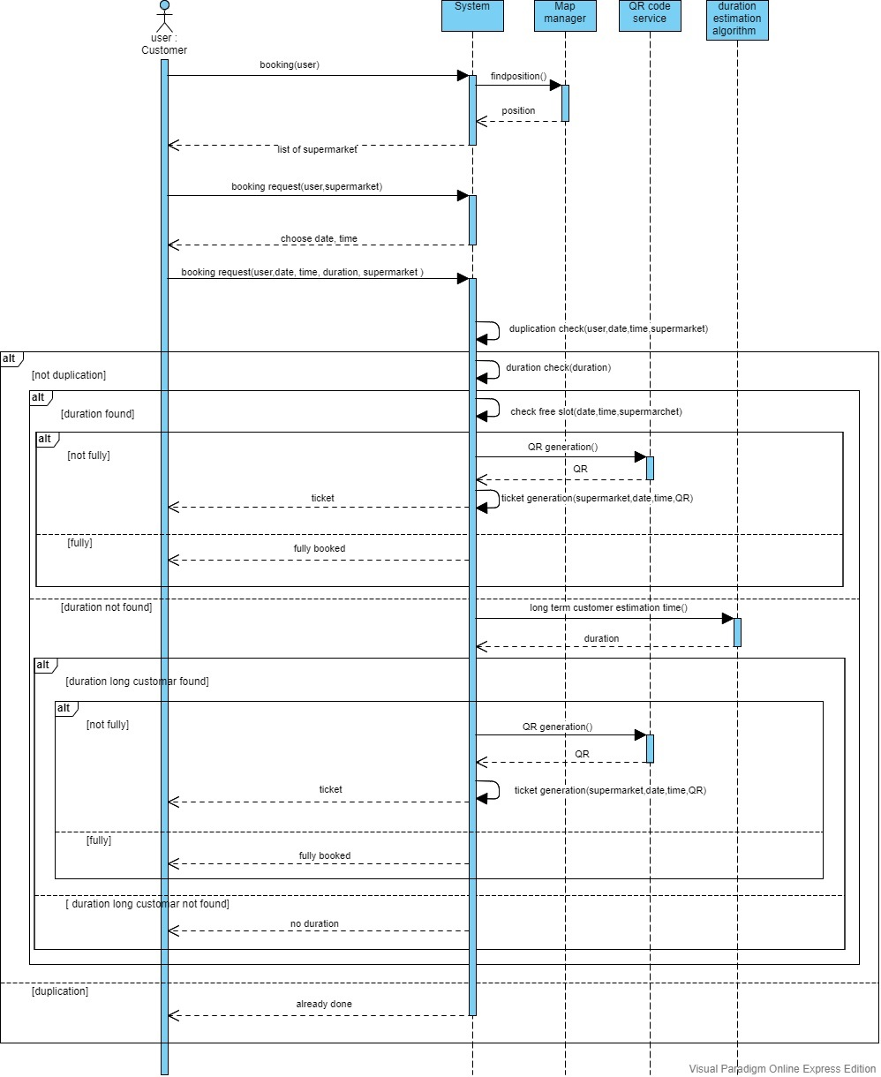

Figure 31:  *Book A Visit Function* Sequence Diagram

UCD5 Insert Shopping List:

|  |  |
| --- | --- |
| Name | Insert shopping List |
| Actors | Customer |
| Entry Conditions | 1. The customer is logged in 2. The customer has just inserted booking date and time |
| Flow of events | 1. The customer clicks on ‘Create a shopping list!’ 2. The customer chooses some categories 3. The customer clicks on ‘Create accurate shopping list!’ 4. The customer chooses some products 5. The system stores data inserted |
| Exit Condition | The customer has inserted shopping list in his booking |
| Exceptions | - |

Table 8: *Insertion of the Shopping List* Use Case Description

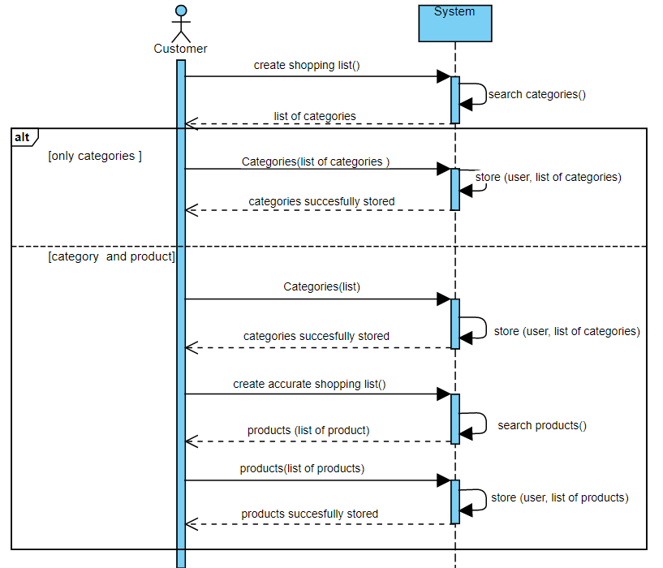

Figure 32: *Insertion of the Shopping List* Sequence Diagram

UCD6 Suggest Alternatives:

|  |  |
| --- | --- |
| Name | Suggest alternatives |
| Actors | Customer |
| Entry Conditions | 1. he customer is logged in 2. The customer has sent Book a visit request without shopping list or with shopping list but the check crowding was not successful 3. The store is fully booked |
| Flow of events | 1. The customer receives Warning Pop Up 2. The customer clicks on ‘Time Slots’ 3. The system finds available slots 4. The system shows alternative time slots 5. The customer chooses an available time slots 6. The system checks alternative received 7. The system stores data |
| Exit Condition | The customer has chosen his preferred alternative |
| Exceptions | * If the check alternative is not successful, this means that the suggested time slots are not what the customer wants and the system suggests other supermarkets available, if the customer chooses another supermarket the system accepts the request otherwise it rejects. |

Table 9: *Alternatives Suggestion* Use Case description

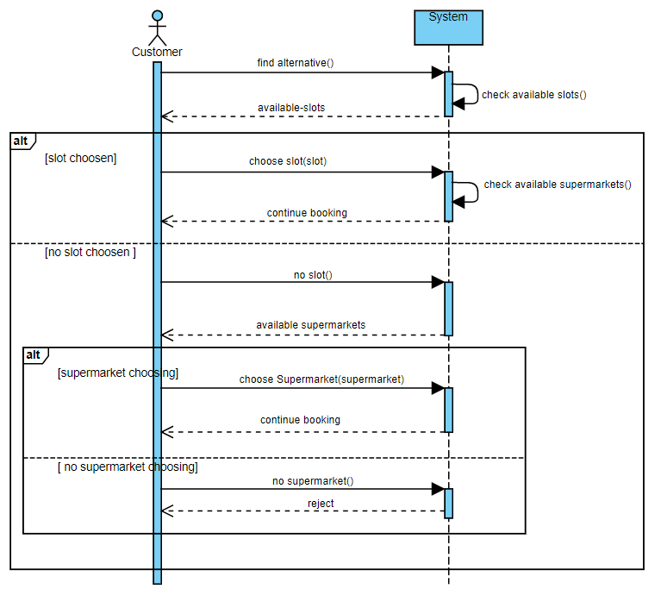Figure 33: *Alternatives Suggestion* Sequence Diagram

UCD7 Turn On Periodic Notifications:

|  |  |
| --- | --- |
| Name | Turn on periodic notifications |
| Actors | Customer |
| Entry Condition | The customer is logged in |
| Flow of events | 1. The customer clicks on ‘Turn on notifications’ 2. The system stored this feature |
| Exit Condition | The customer has turned on periodic notifications on his device |
| Exceptions | - |

Table 10: *Turn On Periodic Notifications Function* Use Case Description

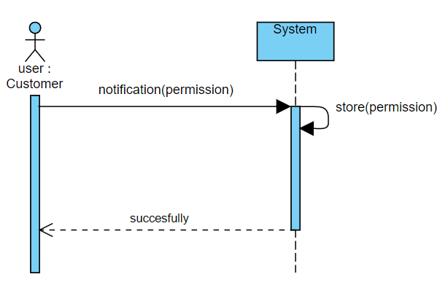

Figure 34: *Turn On Periodic Notifications Function* Sequence Diagram

**Manager**

UCD8 Manager Registration:

|  |  |
| --- | --- |
| Name | Manager Registration |
| Actors | Manager |
| Entry Condition | Manager has started the CLup Web application |
| Flow of events | 1. The manager clicks on sign up button 2. The manager chooses a username and a password 3. The manager confirms his password 4. The manager inserts his email 5. The manager inserts his supermarket identifier 6. The manager accepts the Terms and Conditions of CLup 7. The manager clicks on ‘Register’ button 8. The system checks the username to be unique 9. The system checks the email 10. The system stores the manager data |
| Exit Condition | The manager is registered in the system |
| Exceptions | * If the confirmed password is not the same as the first one, the system informs the manager that the two passwords are different. * If the manager does not have the supermarket identifier or the one inserted is incorrect, he has to click on the link suggested. * If the username inserted by the manager is already used by another user, or if the username contains any special character, the system informs the manager with a message error asking the manager to insert a different one. * If the system finds a duplicate it rejects the request. |

Table 11: *Manager Registration* Use Case Description

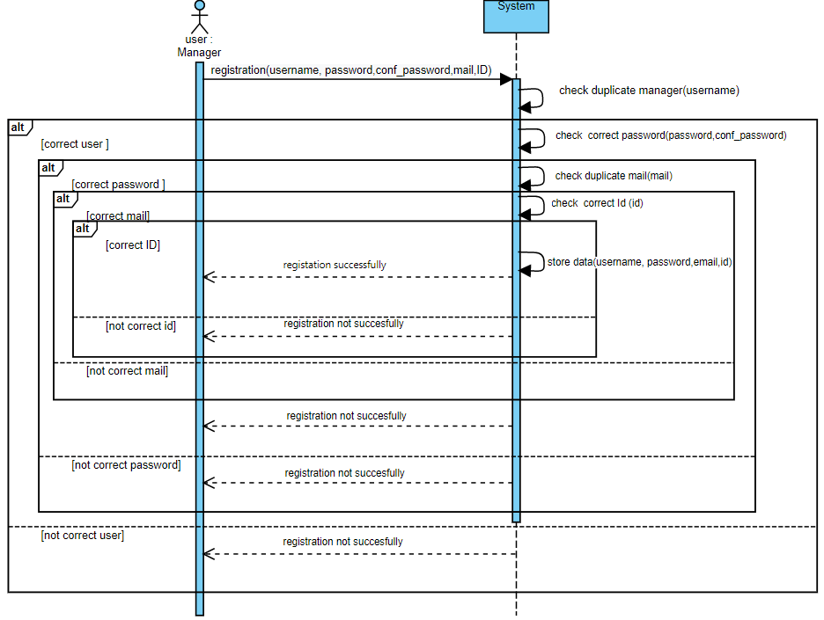

Figure 35: *Manager Registration* Sequence Diagram

UCD9 Manager Login:

|  |  |
| --- | --- |
| Name | Manager Login |
| Actors | Manager |
| Entry Condition | The manager has started the CLup web application |
| Flow of events | 1. The manager inserts his username 2. The manager inserts his password 3. The manager optionally clicks on ‘Remember me’ 4. The system checks the username to be existing 5. The system checks the password to be correct 6. The manager clicks on ‘Send me the OTP code’ 7. The system generates the OTP code 8. The system sends the OTP code to the manager via email 9. The manager inserts the OTP code 10. The manager clicks on ‘Confirm and Login’ |
| Exit Condition | The manager is logged in |
| Exceptions | * If the system does not recognize the username inserted, the manager is not registered yet, or the username is incorrect. The system informs the manager about this. * If the password is incorrect, the system informs the manager to reinsert it. If he wrongs again, the system suggests the manager to reset a new password by sending him an email. * If the manager does not receive the OTP or if he inserts a wrong OTP, the procedure is aborted. |

Table 12: *Manager Login* Use Case Description

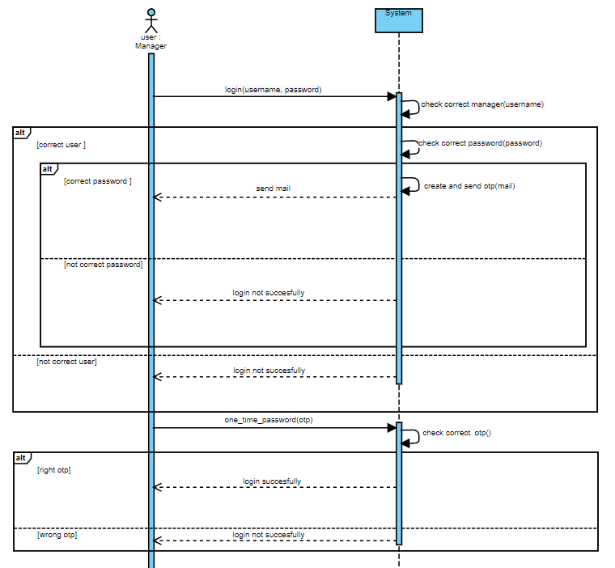

Figure 36: *Manager Login* Sequence Diagram

UCD10 Regulate The Influx Of People:

|  |  |
| --- | --- |
| Name | Regulate influx of people |
| Actors | Manager |
| Entry Condition | The manager is logged in |
| Flow of events | 1. The manager increase/decrease the maximum number of booking/line up requests 2. The system stores the new capacity 3. The system sends info to the QR Scanner |
| Exit Condition | The capacity is changed |
| Exceptions | - |

Table 13: *Regulate The Influx Of People Function* Use Case Description

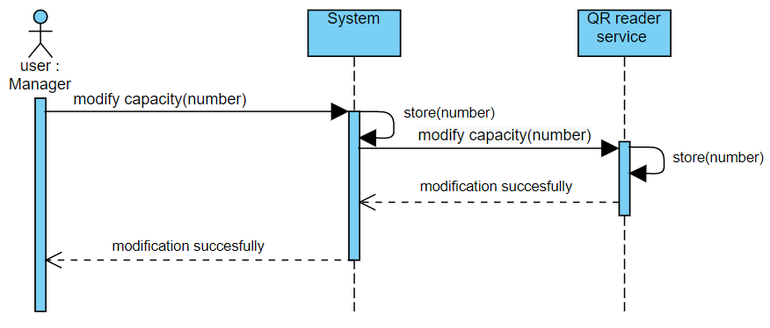

Figure 37: *Regulate The Influx Of People Function* Sequence Diagram

3.3.4 Traceability Matrix

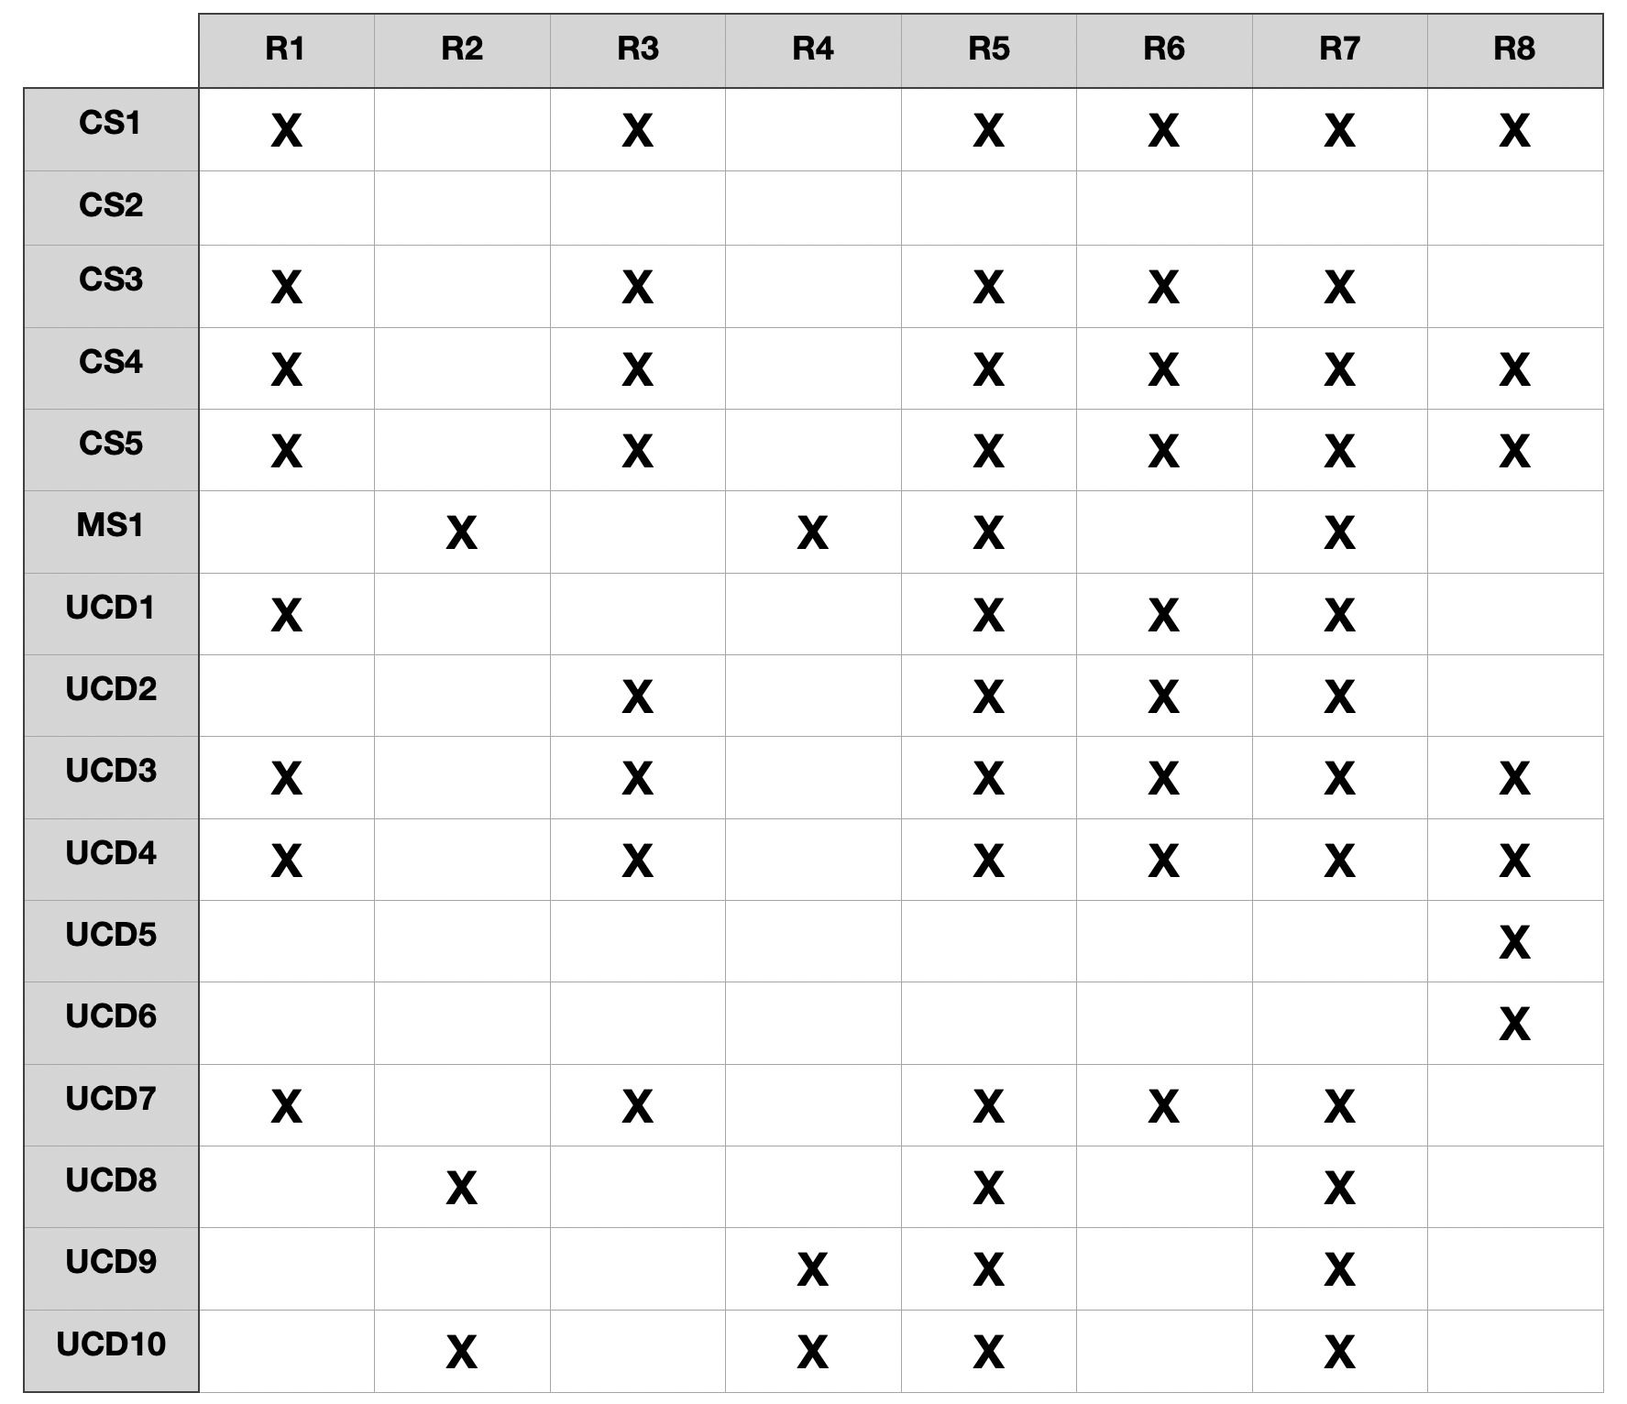

Table 14: Traceability Matrix for requirements from R1 to R8

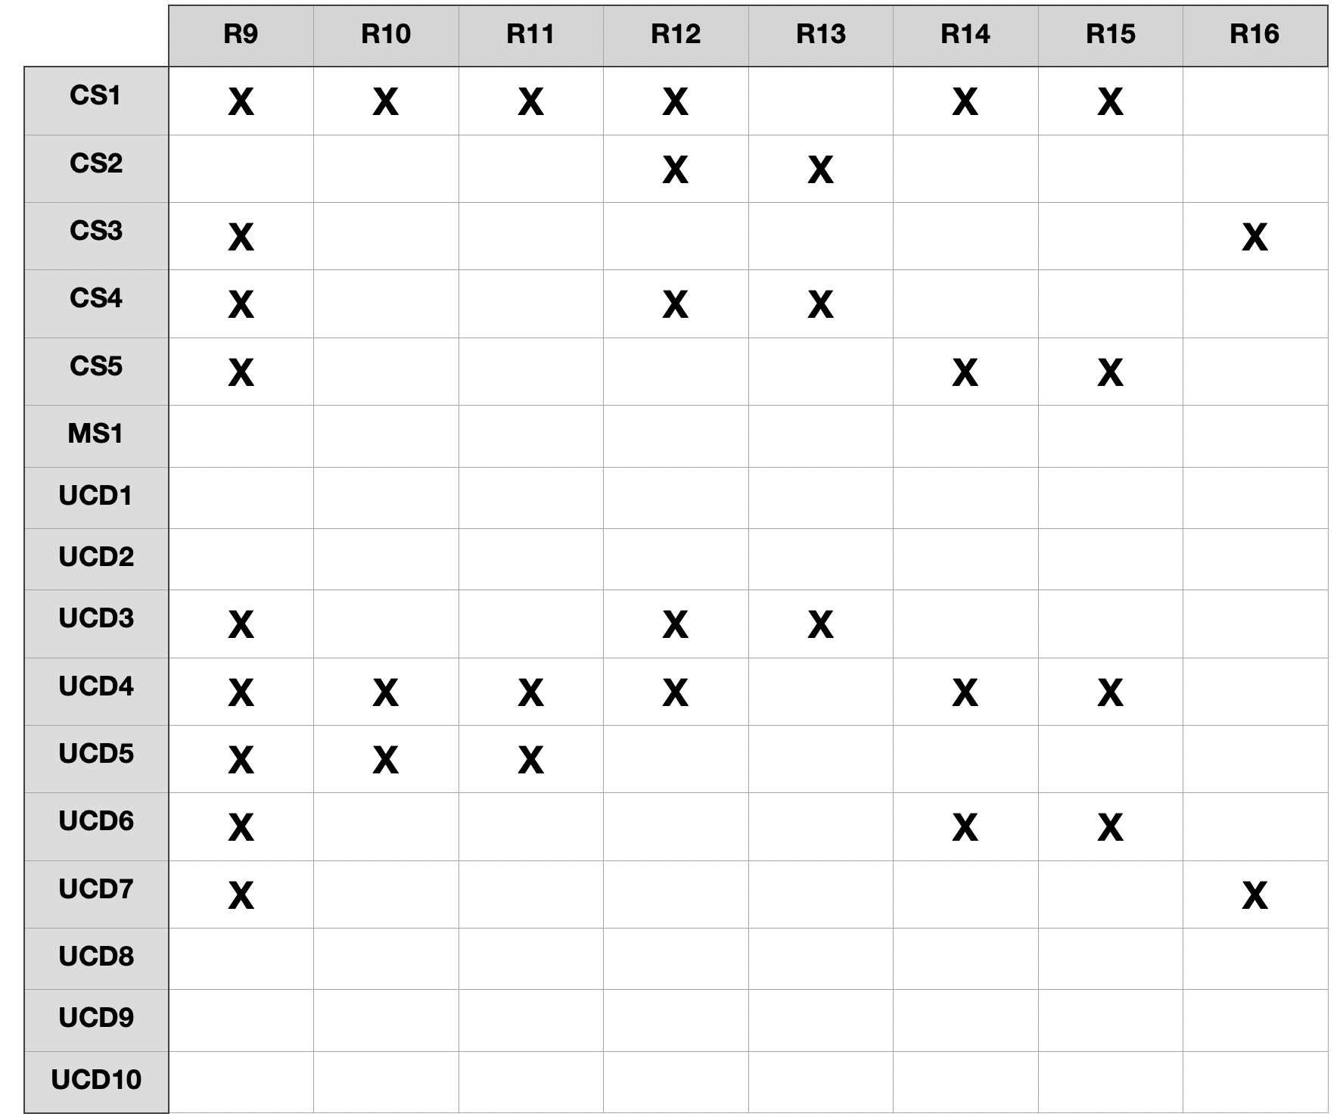

Table 15: Traceability Matrix for requirements from R9 to R16

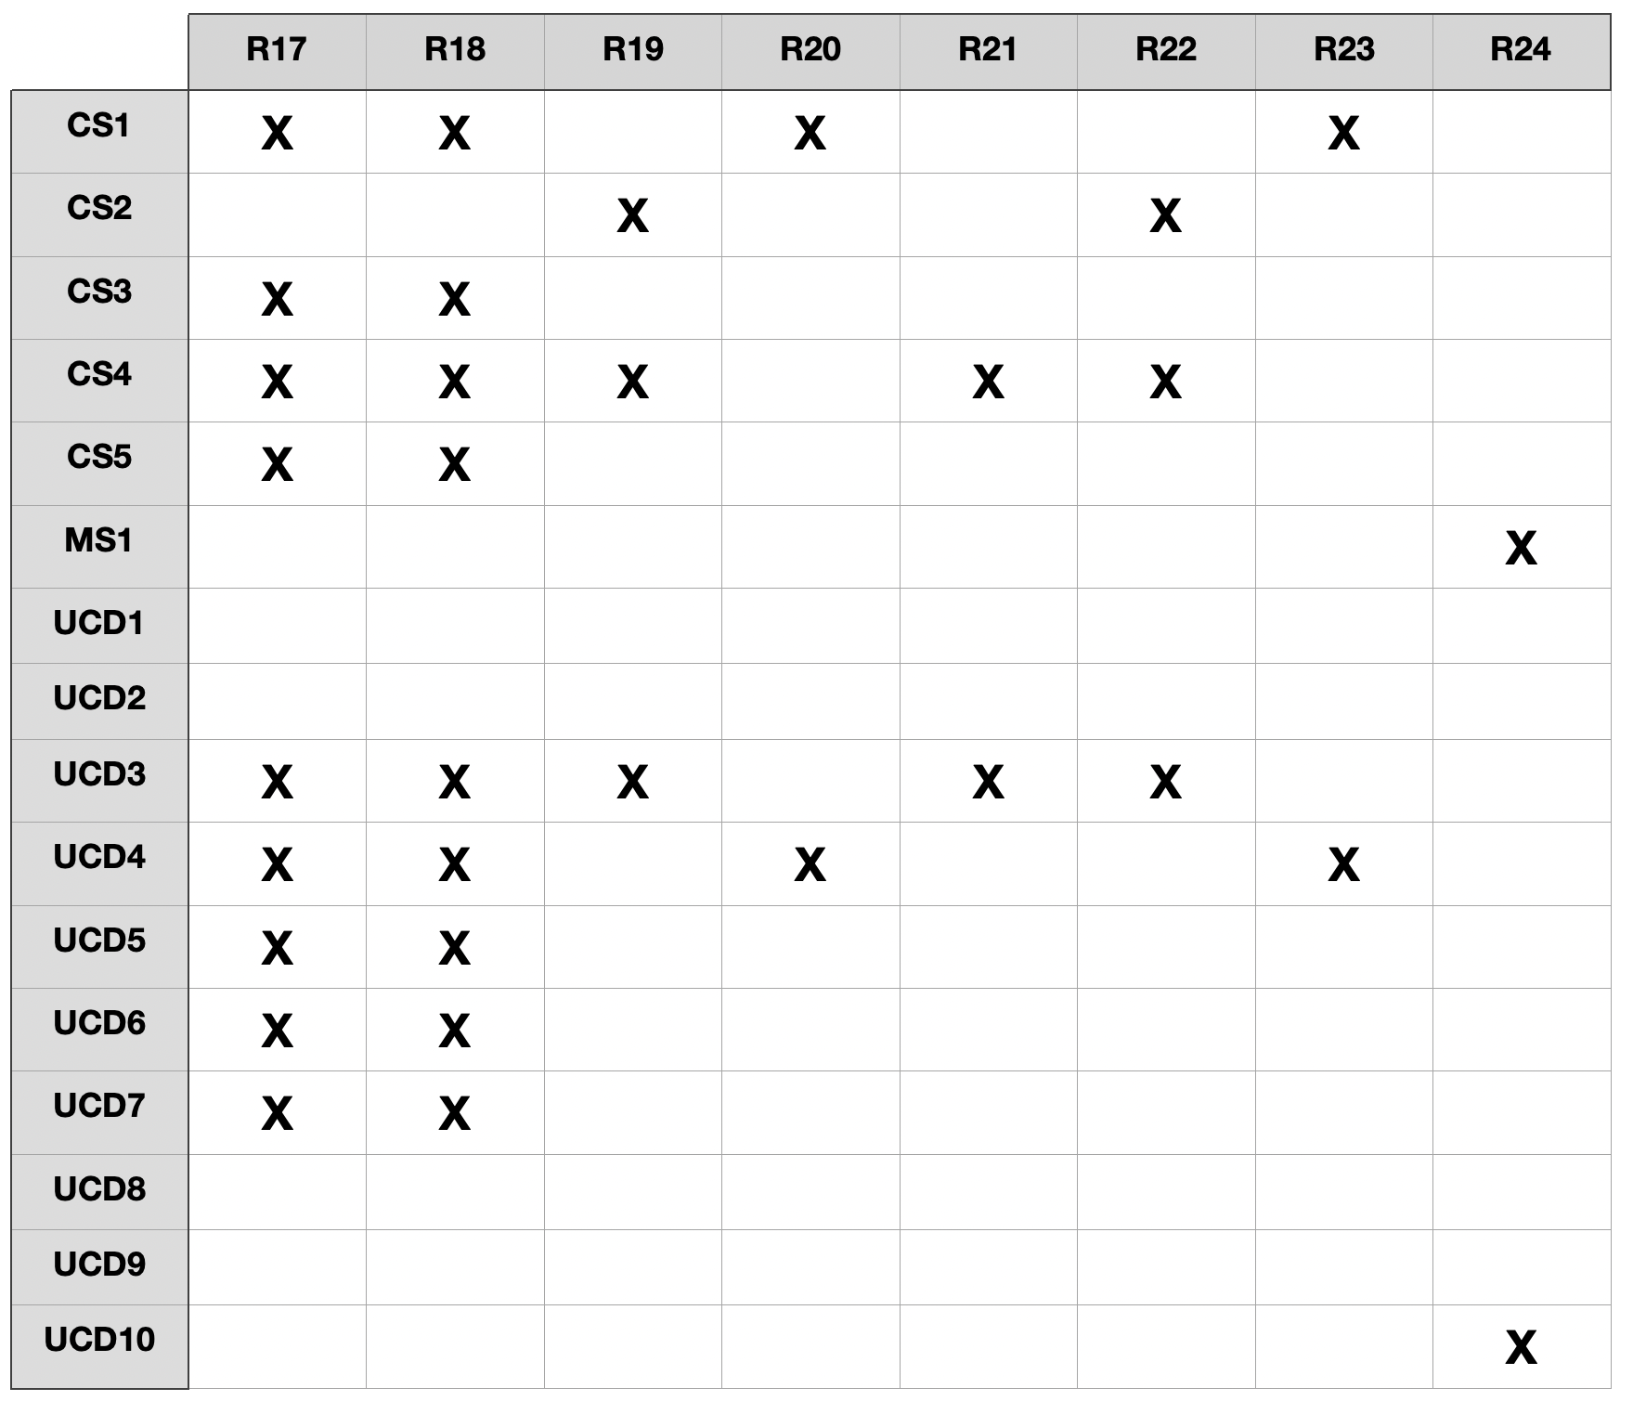

Table 16: Traceability Matrix for requirements from R17 to R24

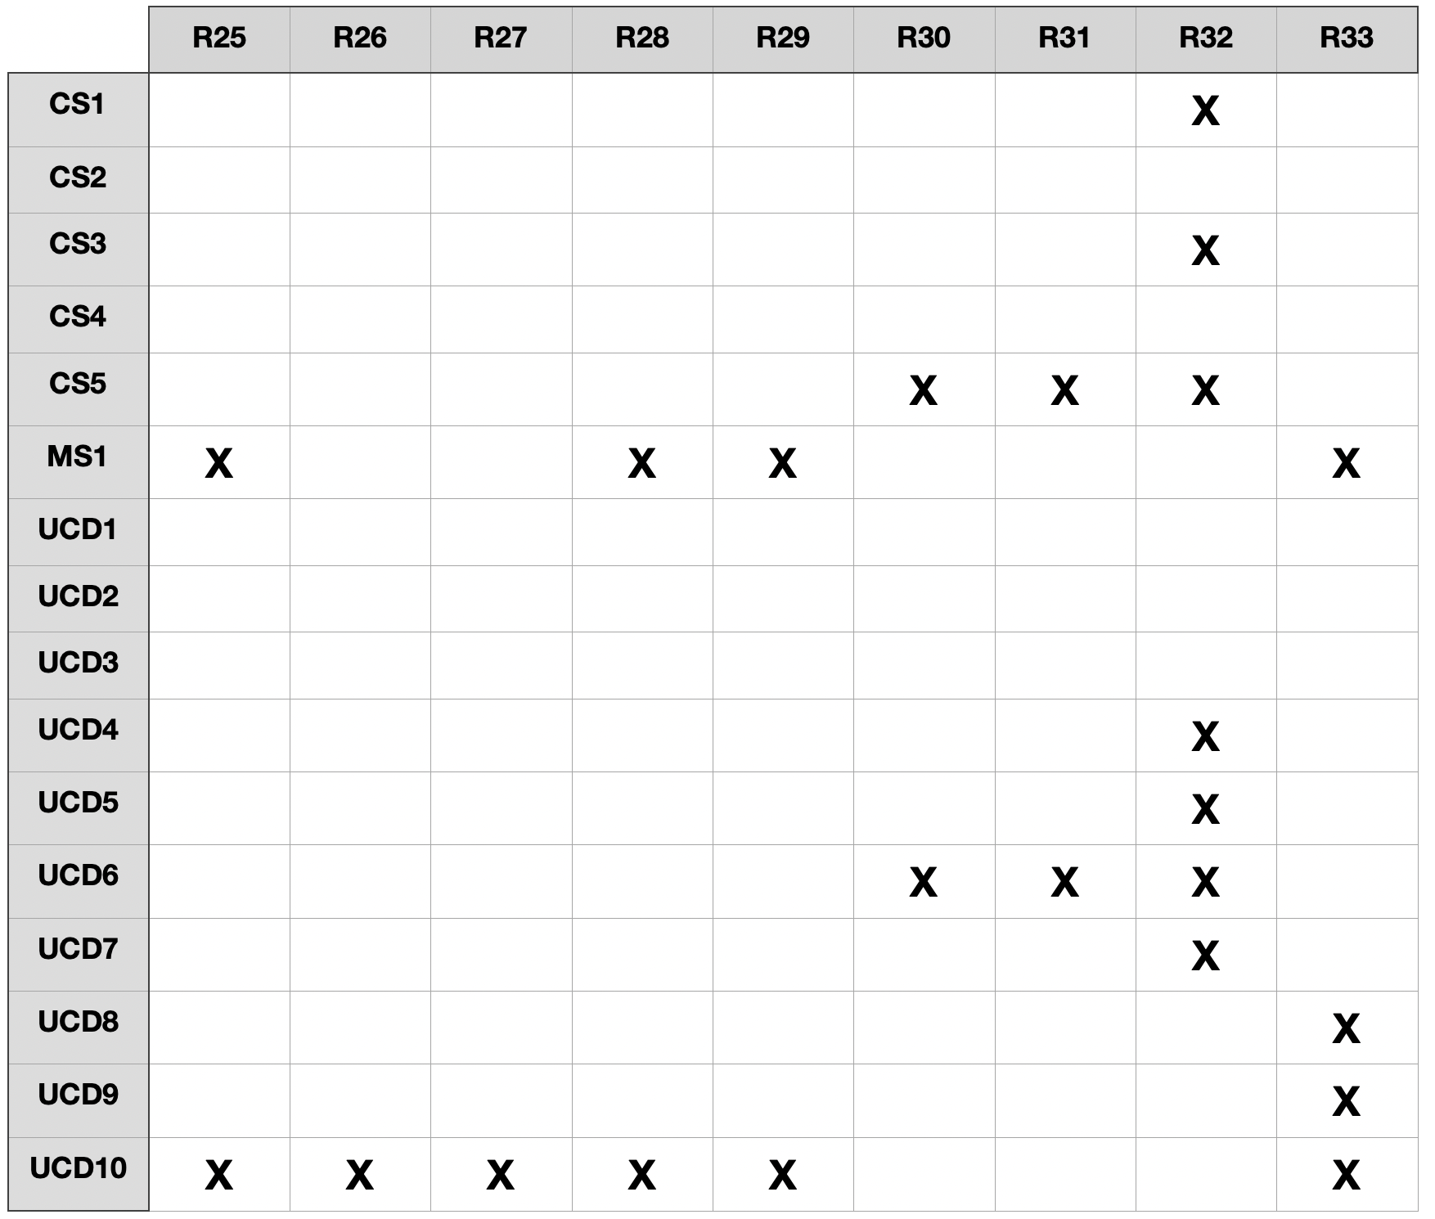

Table 17: Traceability Matrix for requirements from R25 to R33

3.4 Performance Requirements

CLup is an application that allows people to do shopping in a more safe way in such a situation. It must be very efficient because a minimum error can cause a risky situation for the people who are using it and it can throw them into a situation of potential contagion. It must manage very carefully entrances and exits from a store because we want to avoid those people that have a ticket and go to the store at their turn time, and have to wait at the entrance creating undesired crowds. In this case we have assumed that people who are going to the store follow the shortest path to reach the store, because the system cannot control an eventual delay, so CLup guarantees that no crowds are created because it reasonably estimates a precise waiting time and it alerts people when their turns are approaching. Therefore when a client makes a request to the system, it needs to store and respond as soon as possible so that it can also handle people who are making a request at the same time. We can reasonably say that CLup processes requests within 4 seconds. It also needs to be an effective app in fact it has to reach also people who cannot afford such a technology like older people by using Ticket Machine, and it has to be an easy-to-use app simply downloadable on all of devices but also for manager interfaces.

3.5 Design Constraints

3.5.1 Standard Compliance

The language through which CLup system communicates with the other components is a standard language. The interaction with the storage component is standard, it is not implemented, it is as any other standard interaction between a software and a component from which to retrieve data. Moreover the QR ticket release has all the characteristics of a QR code and it needs to be readable by the QR Reading Service.

3.5.2 Hardware Limitations

People who can use CLup and have access to Book A Visit function or Periodic Notifications function (also Line Up function but having a device it’s not mandatory because Ticket Machine at the entrance is available as previously said) must have a device on which the application needs to be installed. Moreover it’s important to remark that devices must have GPS active, in order to retrieve their positions so that CLup can suggest the nearest supermarkets, but also devices able to receive notifications useful for Periodic Notification function.

3.5.3 Any Other Constraint

Any other constraint that is relevant to highlight is the *data security policy* that CLup must respect, users data must be stored because the system has to know how many registered users it has but all of this data can’t be visible to other users, therefore it must comply with the *privacy policy*.

3.6 Software System Attributes

3.6.1 Reliability

CLup should guarantee an high probability of absence of failures and for a certain time period. Components used are such that they can work properly without interruptions for a non-trivial time. We assume a low MTTR (Mean Time To Repair) for a further increase of the Reliability. When the system goes down CLup has to inform users in advance about the issue that has just arisen and what functionalities are not available, in the same way it informs them when the system returns to work correctly.

3.6.2 Availability

CLup shall be continuously available to the user. It must guarantee rapid service recovery in order to minimize downtime (MTTR). It’s relevant to say that CLup needs a better availability during the opening hours of the stores, and therefore with a higher probability during the day, whereas for supermarkets open 24 hours a day even at night but reasonably the requests received are much lower (in an extremely dangerous situation they may be even 0 because stores are not allowed to be open until a certain time). So we can expect an availability of 95% during the night and an availability of 98% during the day.

3.6.3 Security

CLup must have a high level of security even if it does not require a big amount of data to the user. It must protect users data and must not allow other users to have access to different users data. The login and registration procedures of users must always be successful and work without any unexpected events, if a user needs to reset his password CLup always sends encrypted data via mail. For a higher level of security CLup uses OTP to recognize and authenticate managers.

3.6.4 Maintainability

CLup has to be updated within a certain time with bugs and errors correction. In this way the implementation code needs to be well structured and entirely commented in order to promote the readability of the code. Moreover it is written with the highest level of abstraction in such a way future updates or changes will not cause a large change in the implementation. The test coverage must include most of the code (i.e not less that 85%).

3.6.5 Portability

CLup is an easy-to-use application simply downloadable on all stores and therefore available for all operating systems (iOS, Android, …) in such a way there are no restrictions on device types. Instead for what concerns manager it has to be available for all operating systems (Windows, MacOS, …). Therefore since it is an application portability of CLup should not be a problem.

**4 Formal Analys****is Using Alloy**

The following section is dedicated to the analysis of the essential constraints and properties of the CLup software. The model represented is simplified and written explanations are added in the parts where it is not possible to reach an adequate clarification with only the written code.

The same is done in section where it is important the result computed by external services that are obviously not analyzed in this document in detail.

Inside this model we want to prove that:

* There are no duplicated entities of any type.
* Only customers can make requests to the system.
* The notifications are provided by the system only if the customer authorizes them.
* All the reservations made by the application are in available dates and times.
* All tickets are correctly assigned to the customer that makes the request.
* All valid requests are ACCEPTED by the system and the invalid ones are REJECTED.
* And many others less important ones.

4.1 Alloy Model

|  |  |
| --- | --- |
| 1  2  3  4  5  6  7  8  9  10  11  12  13  14  15  16  17  18  19  20  21  22  23  24  25  26  27  28  29  30  31  32  33  34  35  36  37  38  39  40  41  42  43  44  45  46  47  48  49  50  51  52  53  54  55  56  57  58  59  60  61  62  63  64  65  66  67  68  69  70  71  72  73  74  75  76  77  78  79  80  81  82  83  84  85  86  87  88  89  90  91  92  93  94  95  96  97  98  99  100  101  102  103  104  105  106  107  108  109  110  111  112  113  114  115  116  117  118  119  120  121  122  123  124  125  126  127  128  129  130  131  132  133  134  135  136  137  138  139  140  141  142  143  144  145  146  147  148  149  150  151  152  153  154  155  156  157  158  159  160  161  162  163  164  165  166  167  168  169  170  171  172  173  174  175  176  177  178  179  180  181  182  183  184  185  186  187  188  189  190  191  192  193  194  195  196  197  198  199  200  201  202  203  204  205  206  207  208  209  210  211  212  213  214  215  216  217  218  219  220  221  222  223  224  225  226  227  228  229  230  231  232  233  234  235  236  237  238  239  240  241  242  243  244  245  246  247  248  249  250  251  252  253  254  255  256  257  258  259  260  261  262  263  264  265  266  267  268  269  270  271  272  273  274  275  276  277  278  279  280  281  282  283  284  285  286  287  288  289  290  291  292  293  294  295  296  297  298  299  300  301  302  303  304  305  306  307  308  309  310  311  312  313  314  315  316  317  318  319  320  321  322  323  324  325  326  327  328  329  330  331  332  333  334  335  336  337  338  339  340  341  342  343  344  345  346  347  348  349  350  351  352  353  354  355  356  357  358  359  360  361  362  363  364  365  366  367  368  369  370  371  372  373  374  375  376  377  378  379  380  381  382  383  384  385  386  387  388  389  390  391  392  393  394  395  396  397  398  399  400  401  402  403  404  405  406  407  408  409  410  411  412  413  414  415  416  417  418  419  420  421  422  423  424  425  426  427  428  429  430  431  432  433  434  435  436  437  438  439  440  441  442  443  444  445  446  447  448  449  450  451  452  453  454  455  456  457  458  459  460  461  462  463  464  465  466  467  468  469  470  471  472  473  474  475  476  477  478  479  480  481  482  483  484  485  486  487  488  489  490  491  492  493  494  495  496  497  498  499  500  501  502  503  504  505  506  507  508  509  510  511  512  513  514  515  516  517  518  519  520  521  522  523  524  525  526  527  528  529  530  531  532  533  534  535  536  537  538  539  540  541  542  543  544  545  546  547  548  549  550  551  552  553  554  555  556  557  558  559  560  561  562  563  564  565  566  567  568  569  570  571  572  573  574  575  576  577  578  579  580  581  582  583  584  585  586  587  588  589  590  591  592  593  594  595  596  597  598  599  600 | ////////////////////////////////////////////////////////////////////////////////////////////////////  ////////////////////////////////////// SIGNATURES //////////////////////////////////////  ////////////////////////////////////////////////////////////////////////////////////////////////////  **abstract sig** Account {  username: **one** Username,  password: **one** Password,  email: **lone** Email  }  **sig** Customer **extends** Account {  position: **one** Position,  requests: **set** Request,  notification_permission: **one** Boolean  }  **sig** Manager **extends** Account {  supermarkets: **some** Supermarket  } { **#**email=1}  **sig** Supermarket {  position: **one** Position,  supermarket_chain: **lone** SupermarketChain,  line_capacity: **one** Int,  reservation_capacity: **one** Int,  opening_hour: **one** Time,  closing_hour: **one** Time,  closing_days: **set** Date,  available_items: **set** Product,  lineup_requests: **set** LineUpRequest,  bookavisit_requests: **set** BookAVisitRequest  }  {line_capacity>=0 and reservation_capacity>=0}  **sig** SupermarketChain {  supermarkets: **set** Supermarket  }  **sig** TicketMachine {  supermarket : **one** Supermarket,  ticketAccount: **one** Customer //predefined customer of the machine  }  **abstract sig** Request {  customer: **one** Customer,  supermarket: **one** Supermarket,  QRcode: **one** QRCode,  status: **one** Status  }  **sig** LineUpRequest **extends** Request {  entry_number: **one** Int,  estimated_waiting_time: **one** Duration,  estimated_path_time: **one** Duration  }  {entry_number >= 0}  **sig** BookAVisitRequest **extends** Request {  category_list: **set** Category,  shopping_list: **set** Product,  date: **one** Date,  start_time: **one** Time,  duration: **lone** Duration  }  **sig** Notification {  receiver: **one** Customer,  supermarket: **one** Supermarket,  available_date: **one** Date,  available_time: **one** Time  }  **sig** Product {  name: **one** ProductName}  **sig** ProductName {}  **sig** Category {  products: **set** Product}  **sig** Username {}  **sig** Password {}  **sig** Email {}  **sig** QRCode {}  **sig** Position {  street: **one** Street} //position provided by external interface, linked to the  // nearest street  **sig** Street{  name: **one** StreetName,  positions: **some** Position,  city: **one** City}  **sig** StreetName {}  **sig** City {  name: **one** CityName, //for filtering the available supermarkets  streets: **some** Street} //can not be empty, all cities with at least one street  **sig** CityName {}  **abstract sig** StructuredTime {  hour: **one** Int,  minute: **one** Int,  second: **one** Int}  { hour>=0 //&& hour <= 23 and  minute >=0 //&& minute <=59 and  second >=0 //&& second <=59  }  **sig** Duration **extends** StructuredTime {}  **sig** Time **extends** StructuredTime {}  **sig** Date {}  **abstract sig** Status {}  **one sig** ACCEPTED **extends** Status {}  **one sig** REJECTED **extends** Status {}  **abstract sig** Boolean{}  **one sig** TRUE **extends** Boolean{}  **one sig** FALSE **extends** Boolean {}  ////////////////////////////////////////////////////////////////////////////////////////////////  ///////////////////////////////////////// FACTS //////////////////////////////////////////  ///////////////////////////////////////////////////////////////////////////////////////////////  //CUSTOMER  //there aren't usernames without accounts  **fact** NoUsernameWithoutAccount {  **all** u: Username |  **some** a: Account |  u in a.username  }  //there aren't password without accounts  **fact** NoPasswordWithoutAccount {  **all** p: Password |  **some** a: Account |  p in a. password  }  //there are no email without account  fact NoEmailWithoutAccount {  all e: Email|  some a: Account |  e in a.email  }  //all usernames are unique  **fact** UniqueUsernames {  **no disj** a1, a2: Account |  a1.username = a2.username  }  //all email are unique  **fact** UniqueEmails {  **no disj** a1, a2: Account |  a1.email = a2.email  }  //SUPERMARKET  //there are not two supermarket in the same spot  **fact** NoTwoStoresInSamePosition {  **no disj** s1, s2 : Supermarket |  s1.position = s2.position  }  //the supermarket closes after the opening, at least one hour open  **fact** ClosingAfterOpening {  **all** s : Supermarket | s.closing_hour.hour > s.opening_hour.hour or  //24h open supermarket  (s.closing_hour = s.opening_hour)  }  //a supermarket belongs to only one chain  **fact** NoSupermarketsInTwoChains {  **no disj** sc1, sc2: SupermarketChain |  **#**(sc1.supermarkets & sc2.supermarkets)>0  }  //all the supermarkets have one Manager  **fact** NoSupermarketsWithoutManager {  **all** s : Supermarket |  **some** m : Manager | s in m.supermarkets  }  //if a supermarket is in a chain, the chain knows it  **fact** ChainSupermarketConsistency {  **all** s : Supermarket |  **some** c : SupermarketChain |  s in c.supermarkets **iff** s.supermarket_chain = c  }  //if the supermarket is all-day open, the opening and closing hour are at 0:0:0  **fact** ContinuedWorkingHourMidnight{  **all** s: Supermarket |  (s.opening_hour=s.closing_hour) **implies**  (s.opening_hour.hour=0  and s.opening_hour.minute=0 and s.opening_hour.second=0 and  s.closing_hour.second=0 and s.closing_hour.minute=0 and  s.closing_hour.second=0)  }  // STREETS AND CITIES  //there are no streets without cities  **fact** NoStreetWithoutCity {  **all** s: Street |  **one** c: City |  s in c. streets  }  //if a street is in a city, the city has the street  **fact** StreetCityConnected {  **all** s: Street , c: City |  s in c. streets **iff** c in s. city  }  //there are not two streets with the same name in a city  **fact** NoStreetsOmonimousInCity {  **all** s1 , s2: Street |  (( **some** c: City | s1 in c. streets and s2 in c. streets ) and  not (s1=s2)) **implies** not(s1. name = s2. name)  }  //there are no street names without a street  **fact** NoStreetNameWithoutStreet {  **all** sn: StreetName |  **some** s: Street |  sn in s.name  }  //there are no city names without a city  **fact** NoCityNameWithoutCity {  **all** cn: CityName |  **some** c: City |  cn in c. name  }  //one position is only in one street  **fact** PositionOnlyInOneStreet {  **no disj** s1 , s2: Street |  **#**(s1. positions & s2. positions) >0  }  //all the positions are in one street  **fact** NoPositionWithoutStreet {  **all** p: Position |  **some** s: Street |  p in s. positions  }  //if a position is in one street, the position knows the street  **fact** PositionStreetConnected {  **all** s: Street , p: Position |  p in s. positions **implies** s in p. street  }  //PRODUCTS AND CATEGORIES  //all products are in one category  **fact** NoProductInTwoCategories {  **no disj** c1, c2 : Category |  **#**(c1.products & c2.products)>0  }  //there are no products with duplicated name  **fact** NoProductNameDuplicated {  **no disj** p1, p2 : Product |  p1.name=p2.name  }  //there are no product names without the products  **fact** NoProductNameWithoutProduct{  **all** pn: ProductName |  **some** p: Product |  pn in p.name  }  //all products are in one category  **fact** NoProductInNoCategories{  **all** p: Product |  **some** c : Category |  p in c.products  }  //REQUESTS  //all QR codes are different for different requests  **fact** NoDuplicateQR {  **no disj** r1, r2 :Request |  r1.QRcode = r2.QRcode  }  //No QR without a request  **fact** NoQRwithoutTicket {  **all** q : QRCode |  **some** r : Request |  r.QRcode=q  }  //no requests without customer  **fact** NoRequestsWithoutCustomer {  **all** r : Request |  **some** c : Customer |  r in c.requests and r.customer=c  }  //no requests required by different customers  **fact** RequestOnlyOneCustomer {  **no disj** c1, c2 : Customer |  **#**(c1.requests & c2.requests)> 0  }  //correct classification of request in "LineUpRequest" and "BookAVisitRequests"  **fact** RequestInCorrectSet {  **all** r1: Request |  (r1 in r1.supermarket.lineup_requests and r1 in LineUpRequest) or  (r1 in r1.supermarket.bookavisit_requests and r1 in  BookAVisitRequest) or r1.status=REJECTED  }  //LINEUP REQUEST  //we assume that the customer makes the request in days when the supermarket is open  //it's possible to add a check using the retrieved data and time from the device using //similar checks like the ones in the next section.  //The same is possible also for the checking of the hours when the supermarket is open in //order to avoid the overstep of the closing hour with the estimated waiting time.  //We have made this assumption for a better readability in the alloy model.  //all entry numbers are different in the same supermarket  **fact** DifferentEntryNumber {  **all disj** r1, r2: LineUpRequest |  (r1.supermarket = r2.supermarket) **implies** (r1.entry_number != r2.entry_number)  }  //all the lineup requests are related to only one supermarket  **fact** LineUpRequestOnlyInOneSupermarket {  **all** r : LineUpRequest |  **all** s : Supermarket | s != r.supermarket **implies** r not in s.lineup_requests  }  //a lineup request is accepted iff is connected with the supermarket  **fact** RequestAcceptedLineUp {  **all** r: LineUpRequest | (r.status = ACCEPTED) **iff**  (some s : Supermarket | r in s.lineup_requests)  }  //the estimated waiting time is always greater or equal then the time to reach the store  **fact** PathTimeUpperBoundWaiting {  **all** r: LineUpRequest |  (r.estimated_waiting_time.hour >= r.estimated_path_time.hour) or  (r.estimated_waiting_time.hour = r.estimated_path_time.hour and  r.estimated_waiting_time.minute >= r.estimated_path_time.hour) or  (r.estimated_waiting_time.hour = r.estimated_path_time.hour and  r.estimated_waiting_time.minute = r.estimated_path_time.minute and  r.estimated_waiting_time.second >=r.estimated_path_time.second) or  (r.estimated_waiting_time = r.estimated_path_time)  }  //BOOK A VISIT REQUEST  //all the book a visit requests are related to only one supermarket  **fact** BookAVisitRequestOnlyInOneSupermarket {  **all** r : BookAVisitRequest |  **all** s : Supermarket | s != r.supermarket **implies** r not in  s.bookavisit_requests  }  //all the booked visits are in available days  **fact** RequestInAvailableDays {  **all** r : BookAVisitRequest | r.date not in r.supermarket.closing_days  }  //all the booked visits are in available hours  //due to the reduced expressive power of alloy is not easily checkable if  // start_time+duration <= supermarket.closing_hour  //because the sum of the hours, minutes and seconds could overstep the fixed interval  //for example start time: 22:40:00 + duration (00:30:00) = 22:70:00  //take into account this eventuality during the development of the code part  //checks that a request is in available hour  **fact** RequestInAvailableHours{  **all** r : BookAVisitRequest |  (r.supermarket.closing_hour = r.supermarket.opening_hour)  or ((r.start_time.hour < r.supermarket.closing_hour.hour)  or (r.start_time.hour = r.supermarket.closing_hour.hour  and r.start_time.minute < r.supermarket.closing_hour.minute)  and  (r.supermarket.opening_hour.hour< r.start_time.hour)  or (r.supermarket.opening_hour.hour=r.start_time.hour  and r.supermarket.opening_hour.minute<=r.start_time.minute))  }  //a book a visit request is accepted iff is connected with the supermarket  **fact** RequestAcceptedBookAVisit {  **all** r:BookAVisitRequest | (r.status = ACCEPTED) **iff**  (**some** s : Supermarket | r in s.bookavisit_requests)  }  //a book a visit request is rejected and sended to the shoppinglist  //external check iff the capacity is full (NOT PRESENT IN THIS REDUCED //REPRESENTATION)  **fact** RejectRequestOverCapacity {  **all** r: Request | (r.status = REJECTED) **iff**  (#(r.supermarket.bookavisit_requests)= r.supermarket.reservation_capacity)  *//and externalComponentShoppingList () = FALSE, for example*  }  //TICKET MACHINE  //the ticket machine can not make booking requests  **fact** NoTicketMachineBooking {  **no** t : TicketMachine |  **#**(t.ticketAccount.requests & BookAVisitRequest)>0  }  //there is only one ticket machine for each store  **fact** NoDoubleTicketMachine {  **no disj** t1, t2 : TicketMachine |  **#**(t1.supermarket & t2.supermarket) >0  }  //there is only one predefined account for each machine  **fact** NoSamePredifinedAccount {  **no disj** t1, t2 : TicketMachine |  **#**(t1.ticketAccount& t2.ticketAccount) >0  }  //ticketMachine on the same spot of the related supermarket  **fact** TicketMachinePosition {  **no** t1 : TicketMachine |  t1.ticketAccount.position != t1.supermarket.position  }  //the ticket machine cannot obtain notifications from the system  **fact** TicketMachineNoNotifications {  **no** t1 : TicketMachine |  t1.ticketAccount.notification_permission= TRUE  }  //NOTIFICATIONS  //notifications are not duplicated  **fact** NoDuplicateNotification {  **no disj** n1, n2 : Notification |  (n1.receiver = n2.receiver) and (n1.supermarket = n2.supermarket) and  (n1.available_date = n2.available_date)  and (n1.available_time = n2.available_time)  }  //grants that a notification contains only hours in the working hours of the supermarket  **fact** NotificationTimeInWorkingHours {  **all** n: Notification |  (n.available_date not in n.supermarket.closing_days) and  ((n.supermarket.closing_hour = n.supermarket.opening_hour)  or (  (n.available_time.hour<n.supermarket.closing_hour.hour)  or (n.available_time.hour=n.supermarket.closing_hour.hour  and n.available_time.minute<n.supermarket.closing_hour.minute)  or (n.available_time.hour=n.supermarket.closing_hour.hour  and n.available_time.minute=n.supermarket.closing_hour.minute  and n.available_time.second<n.supermarket.closing_hour.second)    and (n.supermarket.opening_hour.hour<n.available_time.hour)  or (n.supermarket.opening_hour.hour=n.available_time.hour  and n.supermarket.opening_hour.minute<=n.available_time.minute)    or (n.supermarket.opening_hour.hour=n.available_time.hour  and n.supermarket.opening_hour.minute=n.available_time.minute  and n.supermarket.opening_hour.second<=n.available_time.second) ))  }  //notification only to customer that allows them  **fact** NotificationOnlyAllowed {  **all** n: Notification |  (n.receiver.notification_permission)= TRUE  }  //TIME AND HOURS  //there is only one time with the same hour, minute and second  **fact** UniqueTime {  **no disj** st1, st2 : StructuredTime |  st1.hour = st2.hour and st1.minute= st2.minute and st1.second=st2.second  }  //////////////////////////////////////////////////////////////////////////////////////////////////  //////////////////////////////////////COMMANDS///////////////////////////////////////  //////////////////////////////////////////////////////////////////////////////////////////////////  **pred** FirstModel {  #LineUpRequest = 1  #BookAVisitRequest = 0  #Customer = 2 //you have to count also the ticket machine users  #Manager = 1  #Supermarket = 1  #Notification=0  #City = 1  #Street = 1  #Position = 2  #Product = 0  #Category = 0  #Date = 2  #TicketMachine = 1  #Password = 3  #SupermarketChain = 1  #QRcode= 1  #Time = 2  }  **run** FirstModel **for** 20 //but 8 Int  **pred** SecondModel {  #LineUpRequest = 0  #BookAVisitRequest = 1  #Customer = 2 //you have to count also the ticket machine users  #Manager = 1  #Supermarket = 1  #Notification=0  #City = 1  #Street = 1  #Position = 3  #Product = 0  #Category = 0  #TicketMachine = 1  #SupermarketChain = 1  #Duration = 1  }  **run** SecondModel **for** 20 //but 8 Int  **pred** ThirdModel {  #LineUpRequest = 1  #BookAVisitRequest = 1  #Customer = (3) //you have to count also the ticket machine users  #Manager = 1  #Supermarket = 2  #Notification=0  #City = 1  #Street = 2  #Position = 2  #Product = 2  #Category =2  #Date = 4  #TicketMachine = 2  }  **run** ThirdModel **for** 20 //but 8 Int  **pred** FourthModel {  #LineUpRequest = 0  #BookAVisitRequest = 0  #Customer = (2) //you have to count also the ticket machine users  #Manager = 1  #Supermarket = 1  #Notification=1  #City = 1  #Street = 2  #Position = 2  #Product = 0  #Category =0  #Date = 4  #TicketMachine = 1  #Password = 3  }  **run** FourthModel **for** 20 //but 8 Int |

4.2 Alloy Clarification

During the analysis using alloy we have noticed some limitations of the tool that can conditionate the model. The bigger problem is related to the “time” concept inside the model. It is possible to place bound limitations regarding the hour/minute/seconds only by modifying the predefined size of the integers. Adding the sentence “but 8 Int” inside the “run” command is possible to modify this setting, in this case is possible to add the constraints “hour <=23 and minute<=59 and second<=59” inside “StructuredTime” for a more precise model. In addition to that it is not possible to correctly compute the sum of a start time and a duration, like better explained in the code without incrementing a lot the complexity of the code. For this reason, we have omitted that part.

Another important aspect, related to the simulation part, is that the number of customers corresponds to the sum of human customers and ticket machines.

In the section below it is possible to read the explanation of the four analysed models, there is also a thumbnail linked to a Drive folder ([Complete diagrams](https://drive.google.com/drive/folders/1UnuVZiZTZMoCJNjQoqbaIJ4NGQosVoen?usp=sharing)) with the images loaded. It is also possible to find the graphs inside the Github folder.

4.3 First Model

In this model (Fig. 38) the focus is on the LineUp service. There is one supermarket with its Ticket Machine that has an account dedicated to the “in person” customers. That account has created a LineUp Request and the other customer (clearly with his Username, Email and Password) is a normal customer using his device without any request active. There is also a Manager, with his own credentials, that manages the Supermarket. The real customer is in a specific position while the Ticket Machine is placed correctly in the same position of the Supermarket. All the usernames are different, and this happens also for the emails. All the Positions are in a Street that is in a City.

Here it is possible to find the graph with an optimal image quality: [First Model.](https://drive.google.com/file/d/15D7i7MDO5psZ8_pzjrWz6G2Oz0BUfixV/view?usp=sharing)

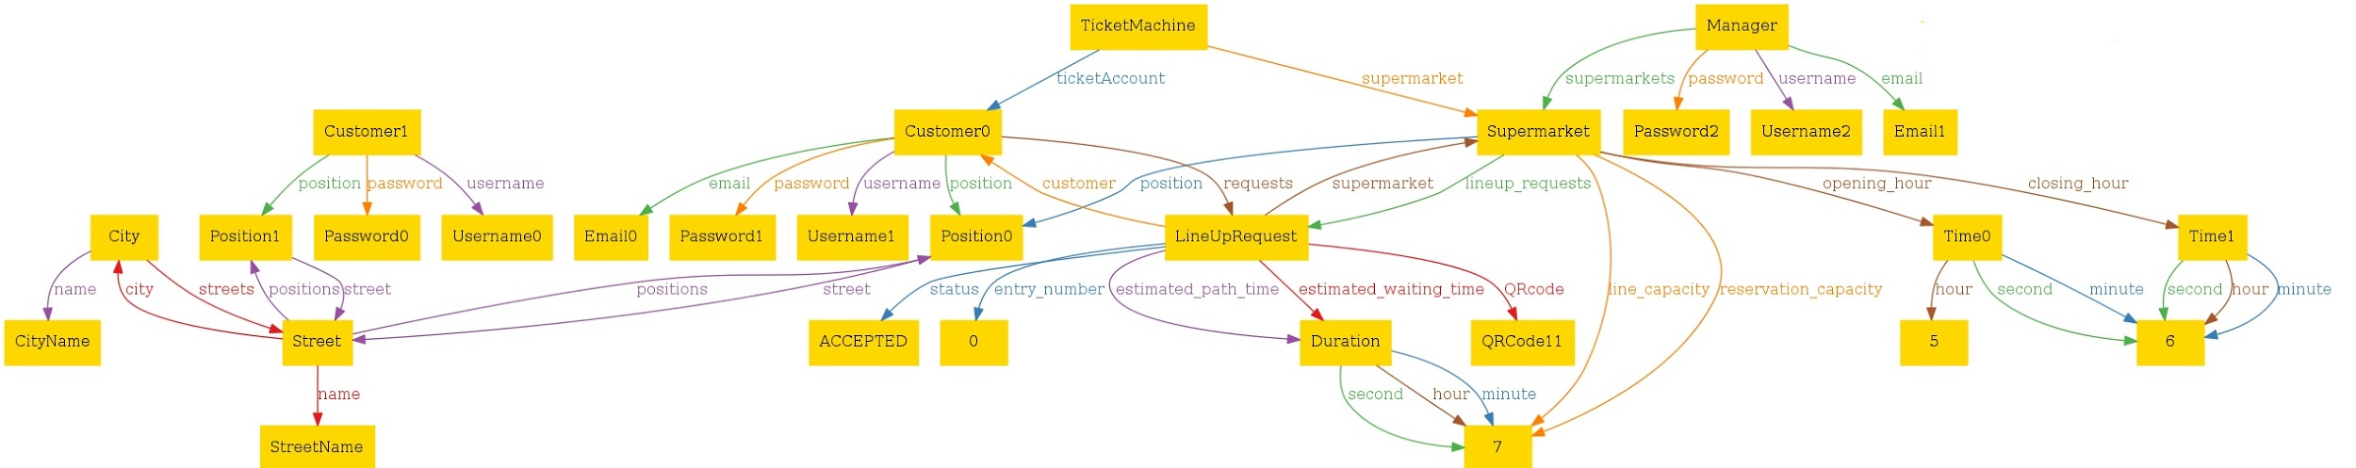

Figure 38: First Model

4.4 Second Model

In this model (Fig. 39) the focus is on the BookAVisit service. There is one supermarket with its related Ticket Machine and one user connected with his device. The customer has created a BookAVisit Request, that is accepted by the system and connected to its QRCode, Date, Starting Time of the visit and Duration. There is also a Manager, with his own credentials, that manages the Supermarket. In this case the supermarket is 24h open. The customer connected with his device is in a specific position that corresponds to the position of the supermarket and the ticket machine. This is a special case, obviously generated by the alloy tool. All the usernames are different, and this happens also for the emails. All the Positions are in a Street that is in a City.

Here it is possible to find the graph with an optimal image quality: [Second Model.](https://drive.google.com/file/d/1T7fU4QsUbT_VPv4KflcUeuJLElEAdj3S/view?usp=sharing)

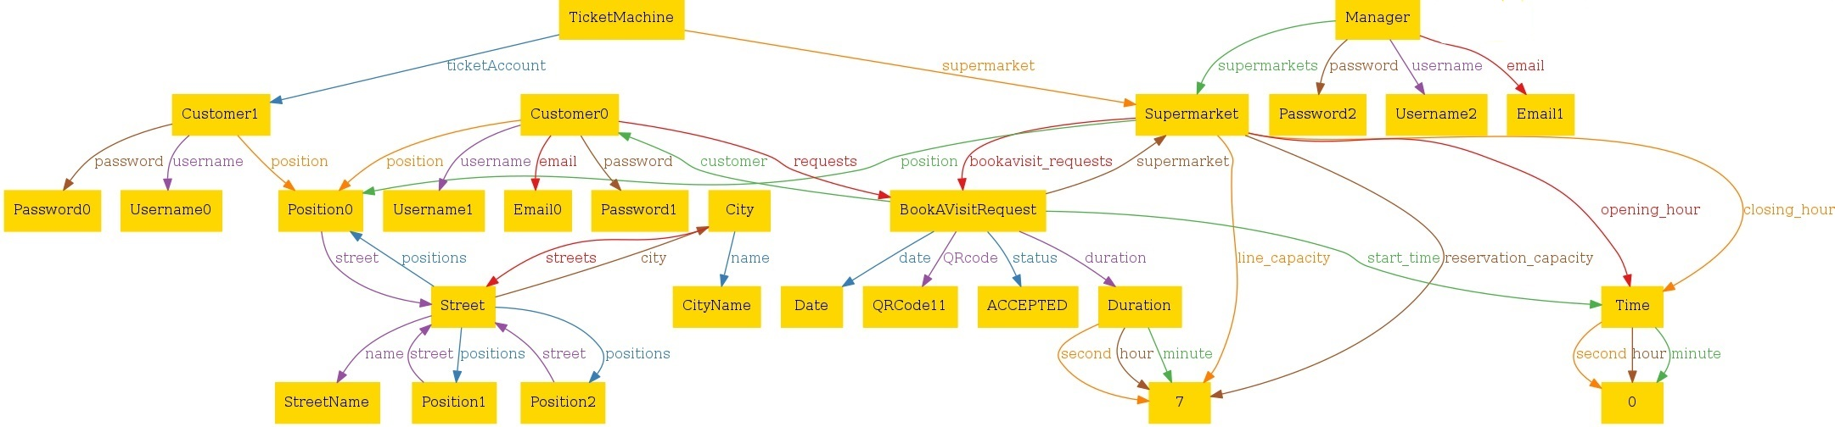

Figure 39: Second Model

4.5 Third Model

In this model (Fig. 40) both the BookAVisit service and the LineUp service are present. The aim of this representation is to show how multiple entities can appear in the model without any problems. In this case there are two different supermarkets, three customers (two ticket machines and one person with his/her device), and both the types of request. Is possible also to see the classification of a group of products in one category on the right side of the graph.

Here it is possible to find the graph with an optimal image quality: [Third Model.](https://drive.google.com/file/d/17I8bmnj2B-wazAPBPkWolHun-PYk2Cmr/view?usp=sharing)

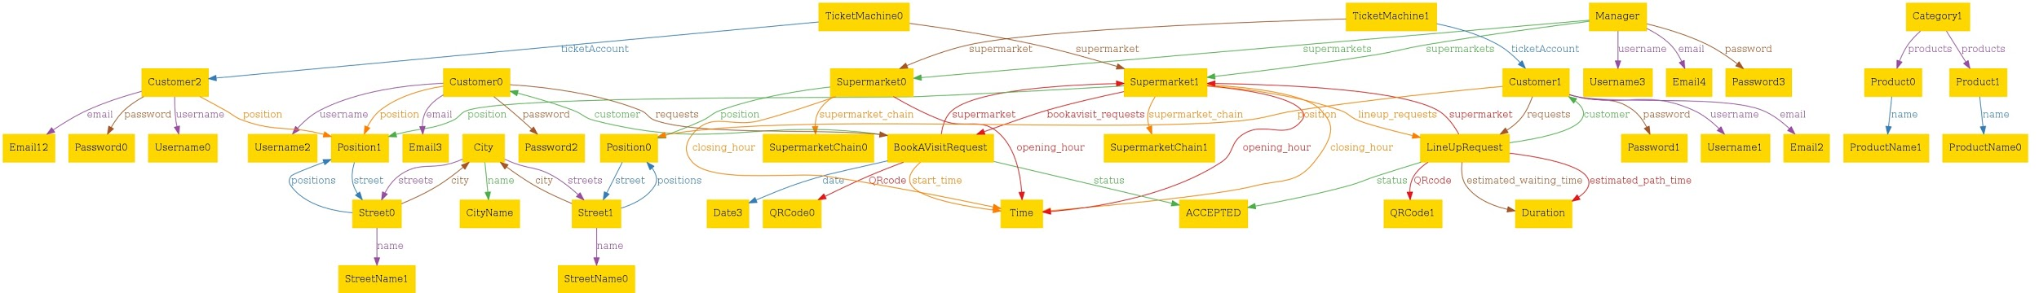

Figure 40: Third Model

4.6 Fourth Model

In this model (Fig. 41) the focus is on the Notification service. There is one supermarket with its related Ticket Machine and one user connected with his device. The customer is notified by the system with a Notification of an available slot and this can happen only because the “allow notifications” flag is set on true value. This notification contains the available date, the available time and obviously the supermarket name. There is also a Manager, with his own credentials, that manages the Supermarket. In this case the supermarket is 24h open. All the usernames are different, and this happens also for the emails. All the Positions are in a Street that is in a City.

Here it is possible to find the graph with an optimal image quality: [Fourth Model.](https://drive.google.com/file/d/1IXxrHHTcps5JFUxPnrepjIJmQY2egBwz/view?usp=sharing)

Figure 41: Fourth Model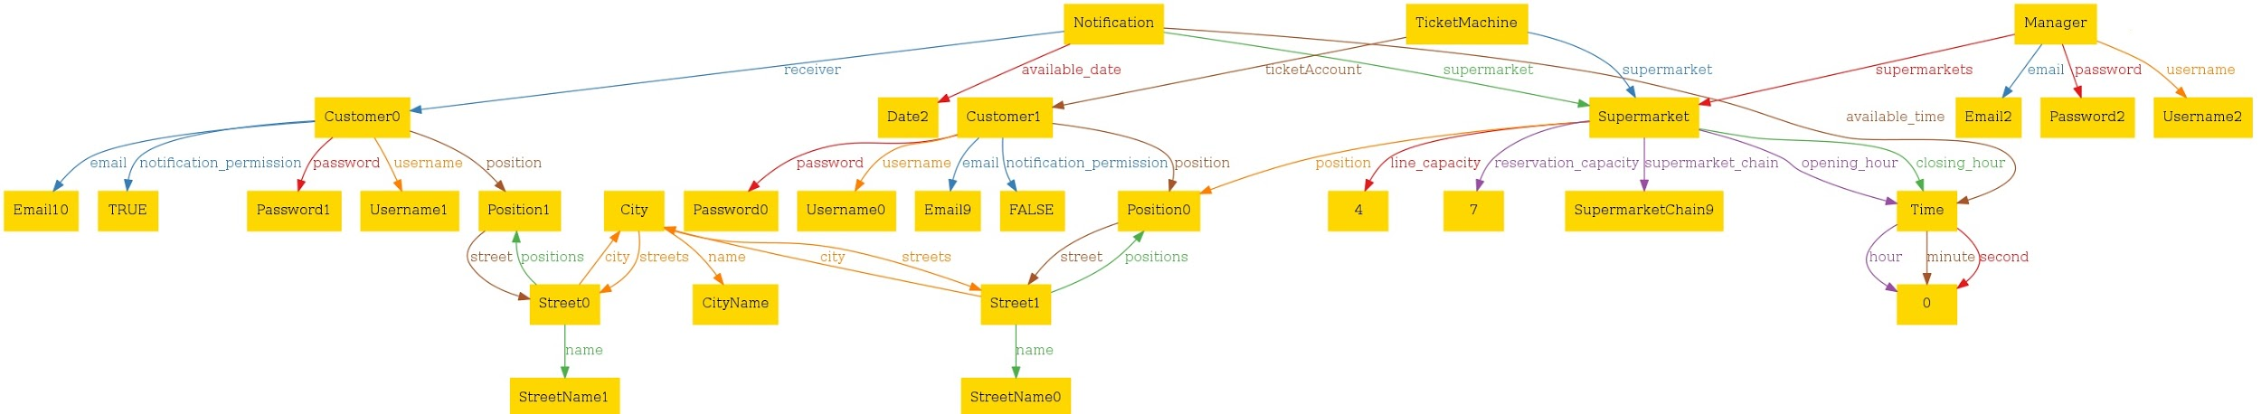

**5 Effo****rt Spent**

5.1 Teamwork

|  |  |
| --- | --- |
| **Task** | **Teamwork’s Hours** |
| Introduction | 2 |
| Product Perspective | 4 |
| Product Functions | 3 |
| Domain Assumptions | 6 |
| External Interface Requirements | 1 |
| Functional Requirements | 4 |
| Non-functional Requirements | 1 |
| Formal Analysis using Alloy | 2 |

Table 18: Teamwork Effort

5.2 Individual Work

|  |  |
| --- | --- |
| **Task** | **Agnese’s Hours** |
| Introduction | 3 |
| Product Perspective | 1,5 |
| Product Functions | 11 |
| Domain Assumptions | 1,5 |
| External Interface Requirements | 1,5 |
| Functional Requirements | 10 |
| Non-functional Requirements | 8 |
| Formal Analysis using Alloy | 3 |

Table 19: Agnese Straccia’s Effort

|  |  |
| --- | --- |
| **Task** | **Cristiano’s Hours** |
| Introduction | 0,5 |
| Product Perspective | 9,5 |
| Product Functions | 1,5 |
| Domain Assumptions | 6 |
| External Interface Requirements | 1 |
| Functional Requirements | 12,5 |
| Non-functional Requirements | 1,5 |
| Formal Analysis using Alloy | 3 |

Table 20: Cristiano Serafini’s Effort

|  |  |
| --- | --- |
| **Task** | **Stefano’s Hours** |
| Introduction | 0,5 |
| Product Perspective | 8 |
| Product Functions | 1 |
| Domain Assumptions | 1,5 |
| External Interface Requirements | 10 |
| Functional Requirements | 2 |
| Non-functional Requirements | 2 |
| Formal Analysis using Alloy | 16 |

Table 21: Stefano Vanerio’s Effort

**Append****ices**

A Revision History

The full revision history is available at this link: [history.](https://docs.google.com/document/d/1EinVh5w7yB-jk7-YYJO_MIyqoS4mnwvOs2p9OUenkZg/edit)

* Version 1.0, online version on Google Docs.
* Version 2.0, final fixes, page enumeration and heading.

B Software and Tools used

* Git & GitHub as version control systems. The repository of the project is [here](https://github.com/Stefano-Vanerio/SerafiniStracciaVanerio).
* Google docs as a collaborative work platform.
* Draw.io for the pictures (interfaces and UML).
* Balsamiq for the mockups.
* Alloy as model analyzer.
* Astah Professional for the state diagrams.
* Visual Paradigm Online for the sequence diagrams and use cases.

**6 Refere****nces**

[1] ISO/IEC/IEEE 29148. Systems and software engineering - Life cycle processes

- Requirements engineering. Technical report, 2011.

[2] IEEE Std 830-1998. IEEE Recommended Practice for Software Requirements Specifications. Technical report, 1998. url: <http://www.math.uaa.alaska.edu/~afkjm/cs401/IEEE830.pdf>.

[3] alloytool.org. Alloy Documentation. Software Design Group. url: <http://alloytools.org/documentation.html>.

[4] Michael Jackson. The world and the machine, 1995. url: <http://mcs.open.ac.uk/mj665/icse17kn.pdf>.

[5] Slides of the lessons, Software Engineering II, Professor Rossi.